m o d e r n v e r v e ®

i n f o @ m o d e r n v e r v e . c o m • 2909 16th ave. s. • seattle, wa., 98144 • (206) 265-2844

PRESS RELEASE

Modern Verve launches Spark Light 3-30 LED Chandelier for 2016

Handcrafted in our Seattle studio, the Spark Light series bursts across the ceiling; creating a distributed light that transforms living spaces. Spark Lights are made of brushed aluminum and slip cast high fire porcelain. Spark Lights can be adjusted to fit the ceiling height of any room.
Spark Lights can be used in intimate living spaces or a focal point in lobbies and reception areas. Spark Light can also be a wonderful atmospheric addition to any dining area, above a table or bar area.
As all of Modern Verve’s lights are, our Spark series is handcrafted in house by Modern Verve in their Seattle studio. All parts are custom made by Modern Verve and use the best lighting technology to protect against over consumption of electricity. Spark lights incorporate the latest in LED lamp technology and are designed and built to last.
The LED technology incorporated in our Spark Light 3-30 Chandelier is so efficient, it would cost only $5.76 a year to operate if you use it 3 hours a day. The money saved on energy can go towards a higher quality fixture, like ours, which is made of real materials such as hand formed glass, porcelain, aluminum and brass that will last a lifetime. We do not use plastics for the shades or bodies since they can discolor, crack and delaminate over time. Now that LED lamps can virtually last a lifetime, we feel a modern LED fixture should do the same.

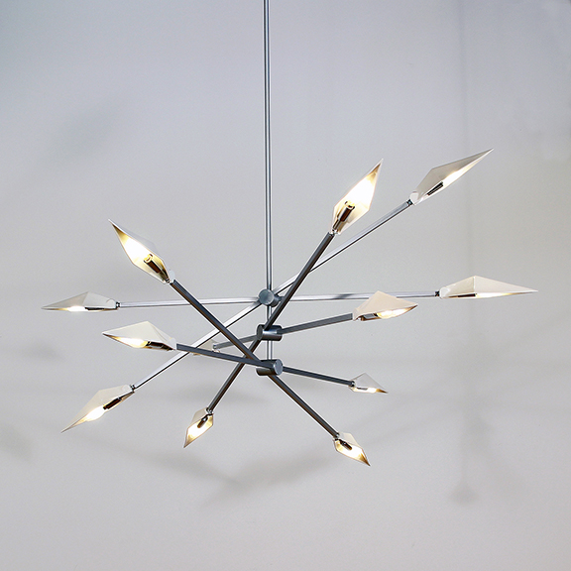

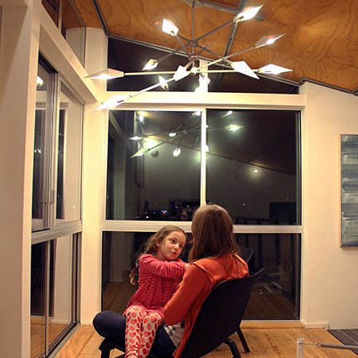

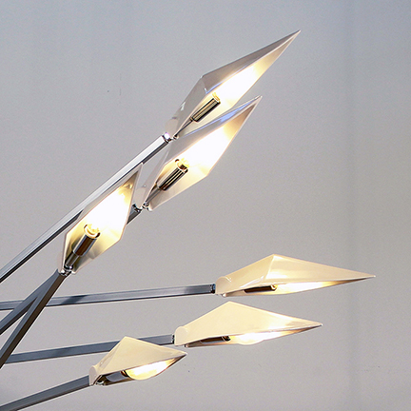
Modern Verve is the creation of Shea Bajaj, a practicing architect in Seattle, Washington. In 2005, Shea began to build a studio space from the ground up with creative investigations as his driving force. Today this beautiful two and a half story modern building provides production, assemblage and design inspiration to Modern Verve designs. All of Modern Verve’s products are produced with an architect’s eye and attention to detail.

