Press Release

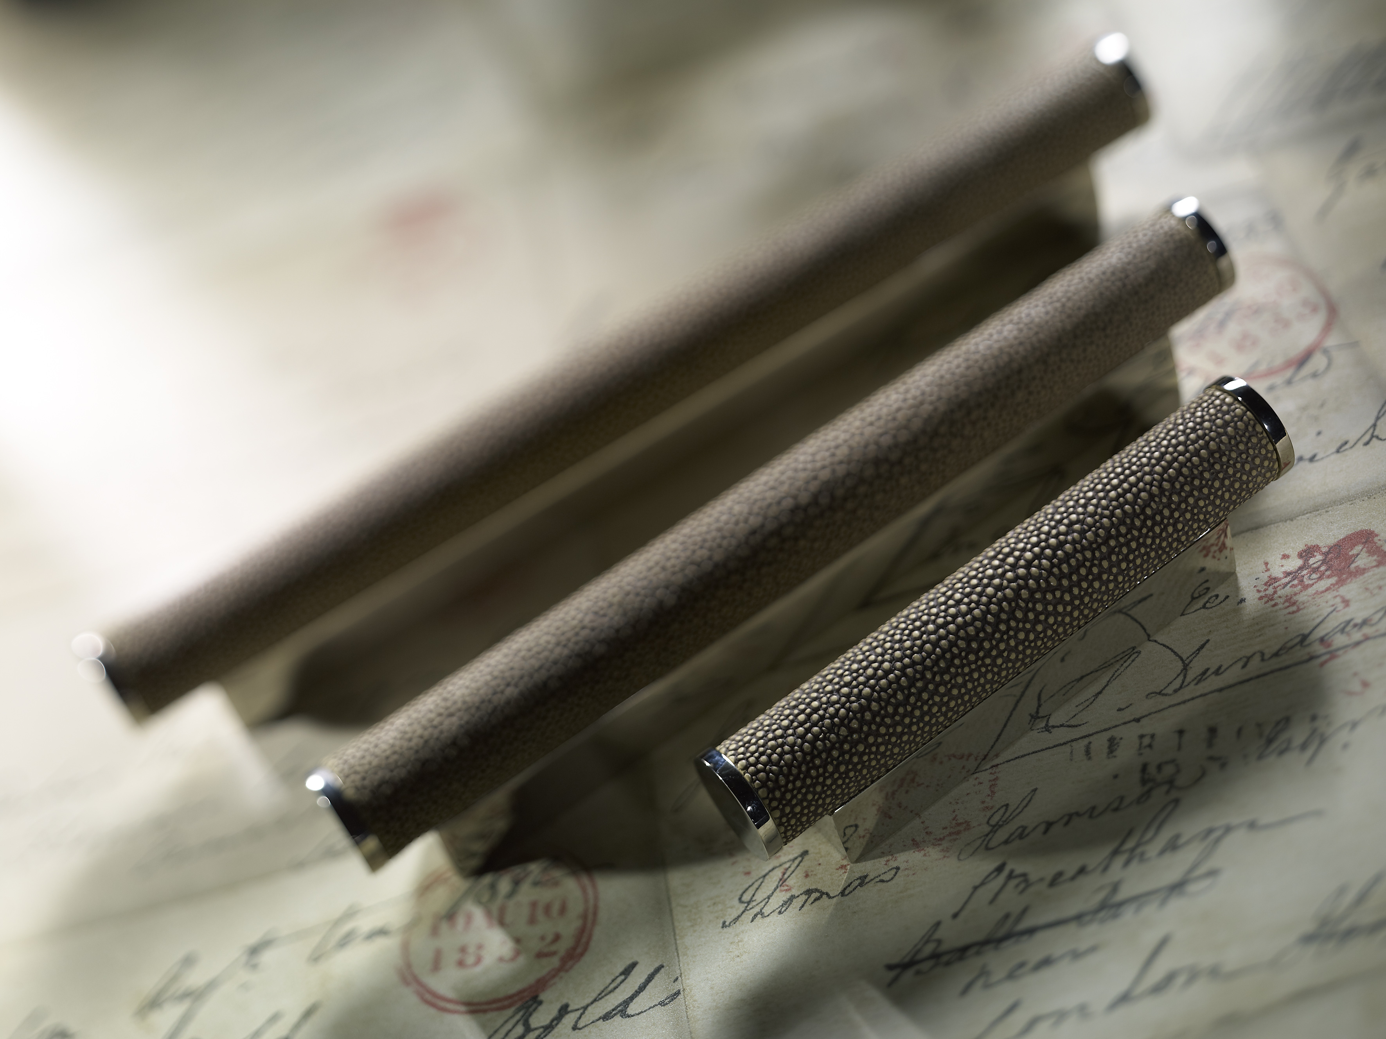
Shown here in Sand Amalfine and Polished Nickel metal finish

Add a touch of the exotic to your furniture –
The shagreen scroll

March 2016;

Turnstyle Designs sees the addition of “Shagreen” to their Scroll furniture hardware collection, previously only available in solid metal or a Leather wrapped / metal combinations to be seen and launched at ICFF.

Managing Director and designer Steve Roberts said “More and more of our clients are looking to upscale their existing furniture or kitchen cabinets. The Shagreen scroll not only adds colour and texture to your cabinetry but is also very practical, having solid bases for covering pre-existing holes.” Turnstyle Designs offer, 7 Amalfine and 7 diverse metal finishes, giving you 49 finish options, enough to co- ordinate with any wood or paint finish.

Available in lengths of 101mm, 155mm and 196mm.

Steve continues “As a design led company we combine materials, textures and finishes to produce beautifully made hardware that adds the finer details to your project ”

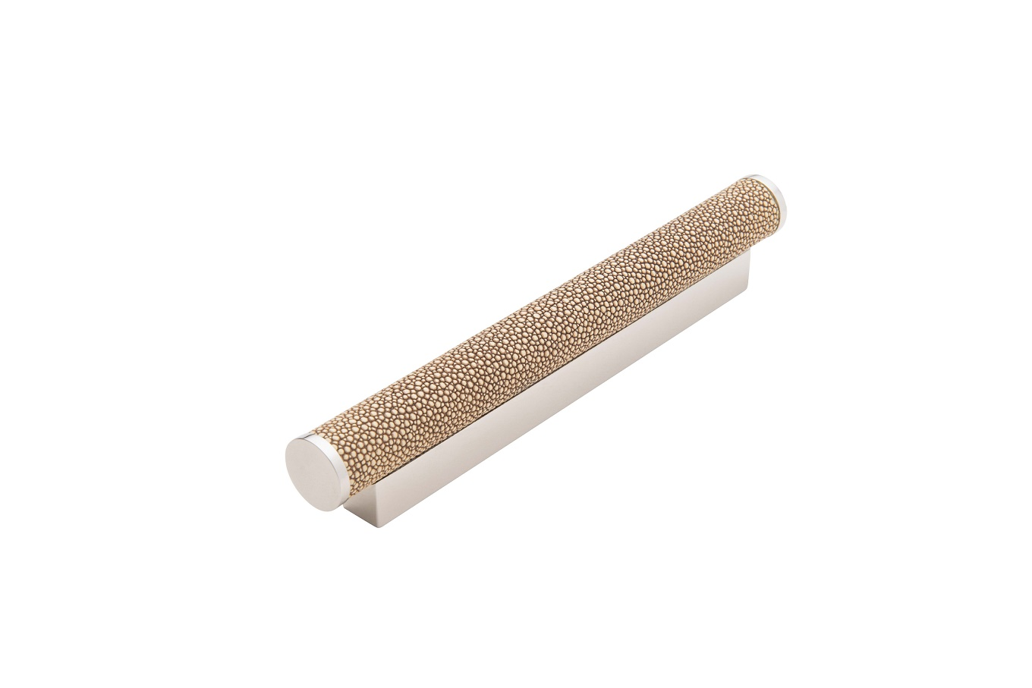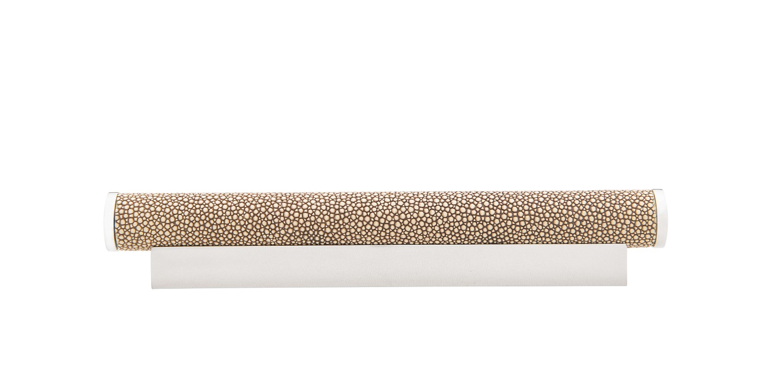
Shown here in Sand Amalfine and Polished Nickel metal finish

Ends

Terms explained:

ICFF – We are exhibiting at ICFF within the BEDG area. Stand Number: 2415 (L1)

Shagreen - Shagreen is now commonly made of the skins of sharks and rays. Turnstyle Design’s environmentally friendly version is a cast from the skin of a stingray and reproduced using their Amalfine™ composite.

Amalfine ™ – Turnstyle Designs own composite blends have become one of our trademarks. The finishes in the Amalfine range are more like materials than finishes, the colour runs throughout the design so unlike a surface finish it cannot wear off.

About Turnstyle Designs Ltd:
Turnstyle Designs have been designing and manufacturing some of the world’s most inspiring door hardware for over twenty years. Using classic materials to create contemporary designs, Turnstyle handles can be found worldwide on some of the world’s most prestigious projects including private homes, yachts, hotels and restaurants. Come and visit our new showroom in the Design Centre East, first floor, unit 103, Chelsea Harbour. www.turnstyledesigns.com or follow us @turnstyledesign

For further information please contact:
Samantha Bruce - Head of PR/Showroom Manager
Email: samantha@turnstyledesigns.com Tel: +44 (0)203 489 1040

