icff nEw york
Ny, 14 / 17 May 2016
Hall 3A / Stand 3718 – 3720

ceadesign S.r.l. s.u
Marketing Department
marketing@ceadesign.it
ceadesign.it/presskit
password: PRESSKIT
+39 (0)424 572309

GIOTTO
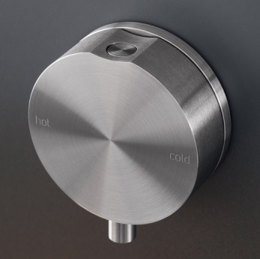
Inspired by pure and archetypal circular forms, the GIOTTO collection is designed in AISI 316/L stainless steel, available in satin and polished finishes. Created to ensure the maximum freedom of composition, GIOTTO expresses aesthetic coherence and functionality. The collection includes a wide range of mixers and accessories repeating circular shapes, which emphasize their perfection. All the spouts are provided with aerators and flow limiters to 5 l/min, ensuring a remarkable water saving. Design by Natalino Malasorti.

INNOVO
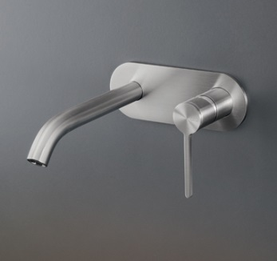
INNOVO continues the CEA project of innovating the conception of sanitary taps. The essential shapes of this mixer hide its strong vocation for technology, as its built-in parts are an industrial patent by CEADESIGN. INNOVO includes the nth CEA industrial patent: the spout of the single hole mixer, by turning on itself, reduces water flow to 2 l/min to perform simple actions that require a little water, such as drinking and teeth brushing. One of the CEA main goals is to educate daily behaviours in respect of the environment and its resources, thanks to simplification and technological innovation. The mixer always opens from cold water, to guarantee energy saving; the aerator provided with flow limiter ensures water saving. Made of AISI 316/L stainless steel, satin and polished finishes. Design by Natalino Malasorti.

UP & DOWN
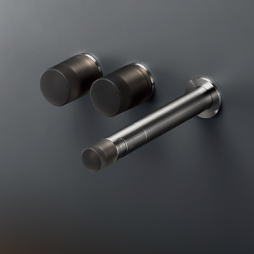
UP & DOWN was born from the encounter between the creative vision of the Brazilian Studio MK27 founded by Marcio Kogan and the expertise and technological know-how of CEADESIGN. Made of AISI 316/L stainless steel in satin finish, UP & DOWN is characterised by details in Technogel®, an ergonomic soft touch material largely employed in the medical sector, available in matt black, transparent anthracite grey and matt silk grey. News for 2014, after few months from the launch at the Salone del Mobile in Milan UP & DOWN has been awarded with the AB Best Product Award 2014. Design by Studio MK27, Marcio Kogan and Mariana Ruzante.

BAR
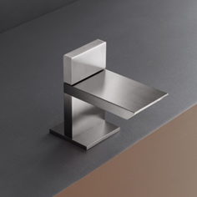
Inspired by essential and timeless geometries, BAR combines formal rigour with a smooth and elegant flow of water. BAR offers a new conception of waterfall jet, which represents the innovative strength of the product: uniting design, water saving and hygiene. BAR collection includes mono and dual lever mixers provided with hydroprogressive ceramic cartridges. BAR is manufactured in AISI 316/L stainless steel, available in satin and polished finishes. All spouts are provided with removable aerators and flow limiters to 7 l/min, ensuring a remarkable water saving and making them very easy to clean from limescale deposits. Design by Natalino Malasorti.

EXCLUSIVE ENVIRONMENTALLY FRIENDLY FINISHES
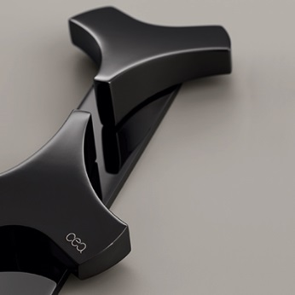
CEA affirms once again its vocation towards innovation with a new concept destined to revolutionize the dressing of steel in the fields of design and faucets. It will be possible to customize all the CEA collections, rigorously made of AISI 316/L stainless steel, along with the charming BLACK DIAMOND (based on graphite and diamond powder) with the new and exclusive finishes: COPPER, BRONZE and LIGHT GOLD. Totally environmentally friendly, they emphasise the natural qualities of the material while highlighting the satin or polished finish. They enrich CEA products with extraordinary properties such as hardness, resistance to scratches, acid and saline solutions, self-lubrication towards lime deposits and glossy shine. The warm, intense tones of copper, the strength of bronze and the retro taste of light gold meet the purity of steel, the design, the durability in time, the technology and the sustainability of the CEA collections.

timeless essences
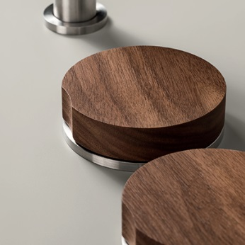
OAK, Burma TEAK, American WALNUT, WENGE are the four exclusive essences that CEA applies to GIOTTO, ZIQQ and BAR controls.
The combination Wood/Steel continues CEA path and restates the ecology as fil rouge of its whole production .
Also the wooden essences, such as stainless steel, are characterized by hardness, excellent resistance to humidity and temperature variations, extreme durability and endurance to acidic solutions or saline.
These features make the product applicable at any condition, even at seaside.

HYDROPLATE
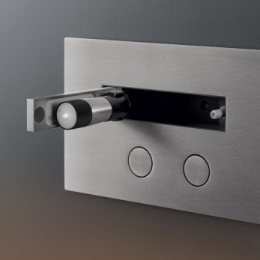
HYDROPLATE is a WC flush plate with flush bottons and a rollaway water jet toilet cleaner or a bidet spray. Made of AISI 316/L stainless steel, polished or satin finishes, the range is available in the new exclusive Black Diamond, copper, bronze and brass versions. Instead of sitting next to the WC as it usually would, the water jet cleaner moves behind a push-to-open hatch, combining a linear design with hygiene and functionality. HYDROPLATE is directly connected to the plumbing system and does not require any additional structural work, being one of CEADESIGN industrial patents. HYDROPLATE has received the prestigious Wallpaper* Design Award 2013 and has been awarded with the selection for GERMAN DESIGN AWARD 2014. Design by Natalino Malasorti.

COMPANY PROFILE

Entering the bathroom sector in 1984, as specialised company in plumbing and installation systems planning, CEA (Centro Energie Alternative) naturally moves to the design sector in 2007. Devoted to innovation, site-specific planning and product re-interpretation, CEA puts its passion, know-how and vision at the service of architects.
Thanks to long-standing experience, CEA offers a truly unique selection of customizable planning solutions, to enable a completely flexible approach towards design and architecture. Every aspect of planning is involved: engineering and technical innovation, installation and architecture, design and innovative materials, regarding to aesthetic value, functionality, sustainability and concern for the environment.
CEA range includes bathroom taps and accessories, kitchen taps, outdoor showers and ceiling fans for air stratification, characterised by low consumption, high performance and flexibility in application.
The whole CEA production is Made in Italy and distributed in prestigious bath furnishing and decor show-rooms worldwide.
CEA develops ideas shaped as bathroom and kitchen taps, manufacturing AISI 316/L stainless steel: a pure, loyal and responsible material.
Pure because stainless steel is 100% recyclable and not chemically treated or varnished.
Loyal because stainless steel is highly performing, with unique characteristics of durability and hygiene as well as of resistance to salt and sulphurous water or the polluted environment.
Responsible because stainless steel is cold-forged: satin and polished finishes are obtained through lathe mechanical processes, optimising water and power consumption in respect of the environment. Totally recyclable, stainless steel promises eternal life, requires minimal care and can always be mechanically renovated.
CEA realises clean forms with a strong technological bias, in the constant listening of the market, to add value to designers’ work and anticipate their needs.
CEA promotes the culture of technology, design and well-being in CEAlab: the company magazine collecting some of the most significant international projects realised by retailers, architects and interior designers featuring CEA products.

TECHNOLOGICAL  INNOVATION  CEA (Centro Energie Alternative) invests its know-how in the research and development of technological solutions for project design. The origins of its expertise trace back to its experiences in the plumbing and installation planning fields, combining technical know-how and architectural demands. The internal research into the product and its peculiarities is careful and aims at supporting the construction work, through simplification, rapid installation and guaranteed operation. Several industrial patents and utility models enable a flexible approach to planning and reduce the time of construction. |  | CULTURE  OF PRODUCT  CEA deals with real experiences to enhance a culture of product and share it for the development of new aware product ideas. The topics of technological innovation, sustainability and aesthetics are the founding elements of the research set with the University of Ferrara and of the training events organised in studios and showrooms worldwide. |  | TIMELESS  DESIGN  Simple and linear geometries demonstrate a deep knowledge of design and can dialogue with architecture beyond time. With CEA collections, architects and designers get a total freedom of style and product combination, which gives wide space to ideas and shape to their realisation. |  | MADE  IN ITALY  CEA totally produces in the Bassano del Grappa district of the North East of Italy, worldwide renowned area for the mechanical engineering tradition, where quality and reliability derive from local synergies. The production process is characterised by precision and manufacturing engineering: simplicity and craftsmanship guide technological innovation and sustainability.
TOTALLY  RECYCLABLE  To master the flow of water, CEA chooses AISI 316/L stainless steel, a totally recyclable and highly performing material. The raw allow, characterised by low levels of carbon, is carefully selected and enables CEA not to involve hot melting, painting, galvanic treatment or other chemical processes during production. Resulting CEA taps do not to release any toxic elements into water, are highly hygienic and totally recyclable. |  | ECO FRIENDLY  PRODUCT  AISI 316/L stainless steel is a particularly hard material and guarantees long life because resistant to scratches, the polluted environment, saltiness and sulphurous water. The characteristics of the material are one of the primary guarantees of product quality, as everlasting and eco-friendly. |  | WATER  SAVING  In CEA product range, the water flow is adjusted by aerators and limiters (reducing the flow to  5 lt/min) and by progressive cartridges (allowing a constant water flow to 5 lt/min while permitting temperature adjustment, with just one movement). Both systems ensure a remarkable water saving, compared to traditional faucets. |  | LOW ENVIRONMENTAL  IMPACT  CEA adopts only cold working methods for stainless steel and does not influence global warming. All the energy that powers production is certified clean, water is saved and waste is separated to be recycled, to reduce the impact of the company on the ecosystem. Thanks to precision CNC machines (lathes, milling and laser cutting) the quality of the production process achieves excellent results. Finishes are obtained through environmentally-friendly mechanical processes.

