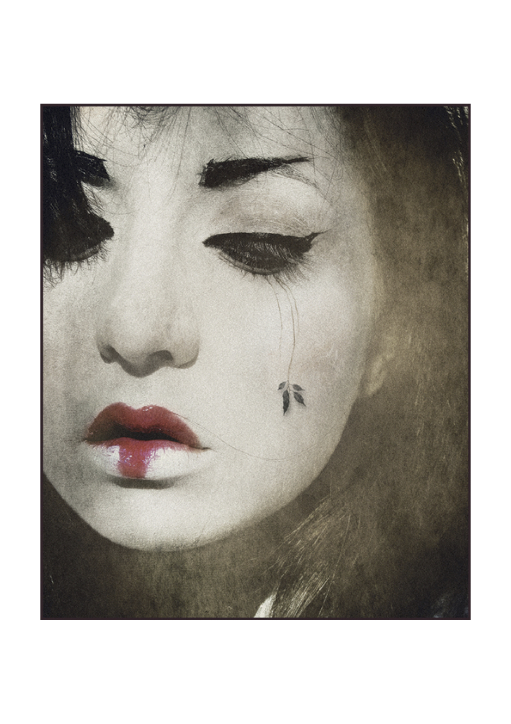

April 28th 2016
Mineheart Brings British Eccentricity to ICFF
Designers Young and Battaglia are bringing their playful and eccentric Mineheart brand to the International Contemporary Furniture Fair for the first time and will be showcasing a characteristically intriguing new lighting and rug collection.
Launching at ICFF will be the brand new Japanese Repose Rug produced in collaboration with artist Himitsuhana. Inspired by the traditional style of the Japanese geisha, Himitsuhana has created this striking black and white portrait pierced with vivid lipstick red. The rug is an example of Mineheart's many collaborations with internationally renowned artists and product designers.
Also new at ICFF will be the King Edison Ghost which features a miniature brass chandelier inside a hand-blown black glass shade and represents the collision of two design genres; the factory edison bulb with the Renaissance King chandelier. The King Edison is the perfect example of how Young and Battaglia like to merge different periods and styles to create something new, contemporary and daring.
“The idea behind Mineheart is to create a playground for creativity and discovery, where art meets design, and poetry meets industry. We try to inject a sense of wonder into everyday objects and spaces around us, telling stories and creating things that are truly surprising,” Young&Battaglia
The lighting collection showing at ICFF will include the recently launched Feather Lamp. The Feather Lamp features a ring of softest Ostrich feathers held in place by slender gold arms. It comes in white or black and in pendant and table lamp styles. Also new are the pop-art inspired Marilyn and Audrey lamps that feature the eyes of these well known movie icons.
Mineheart will also be presenting a selection of their British-made furniture, home accessories and wall art.
Mineheart Background:
Established in 2010, the Mineheart brand combines Battaglia's Italian love of classical art with Young's eccentric British wit to create a compelling collection. Over the last five years the brand has grown and they now have more than 150 products including wallpaper, lighting, furniture and accessories and sell all over the world. The Young and Battaglia design consultancy works with interior designers and architects to create show-stopping high-end spaces.
To see more: www.mineheart.com

Media Contact: Contact 0845 467 4580 enquires@mineheart.com

