ERCOL’S NEW UPHOLSTERY COLLECTION, OFFICE AND LIVING RANGES
TO BE PRESENTED AT ICFF IN NEW YORK IN MAY 2016

Stand 1648, ICFF, Javits Center
New York, 14-17 May 2016
April 2016

Established British furniture company ercol is looking forward to returning to ICFF in May to present a range of new designs for the office and the home, hand-crafted in oak, beech and walnut with high-quality upholstery.

Rho Collection by Matthew Hilton
ercol is delighted to showcase the US debut of a brand new collection of sophisticated seating by British designer Matthew Hilton for ercol. The Rho Chair has shaped angled oak legs beneath a stylish, upholstered seat and back with smooth curves, deep cushioning and an accompanying bolster style cushions for extra comfort as well as a decorative detail. The Rho Two-Seater Sofa shares the Chair’s soft curves and deep seating, and is also available as a Three-Seater Sofa for those looking for more generous proportions. Available in a range of fabrics including Kvadrat Hallingdal fabrics, the Rho Collection’s versatility and style will allow each piece to work equally well within a business environment or a living area.

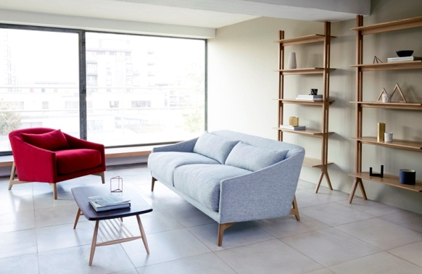
Rho Chair, Rho Sofa and Pero Tall Shelving by Matthew Hilton for ercol
Pero Collection by Matthew Hilton
Matthew Hilton designed the Rho Collection to accompany his new Pero Collection, first glimpsed at Maison & Objet in Paris in January. This modern range was designed to be aesthetically attractive yet functional in a home study environment – with its compact, adaptable shelving and desk – but also works successfully in more domestic settings like living areas, bedrooms or a hallway. The Pero Low Shelving and Tall Shelving units have a distinct elegance. Designed to work as a pair or independently, the linear framework, shallow depth and adjustable shelving offer flexibility and versatile storage for small spaces and city-living as well as awareness for cabling management. Small pins sit behind each shelf keeping cables secure and out of sight, allowing them to run neatly down the back of the upright.

Matthew Hilton has designed the Pero Desk with a similar, subtle attention to detail. At the front of the Desk the shallow drawer runs full width offering useful storage for stationary and paperwork, as well as discreet space for cosmetics or jewellery. Lined with soft-textured matt linoleum in a conifer colour, this versatile material is hard-wearing, modern alternative to traditional leather. At the back of the Desk, an easily accessible black metal cable tray can store multiple cables securely and discreetly.

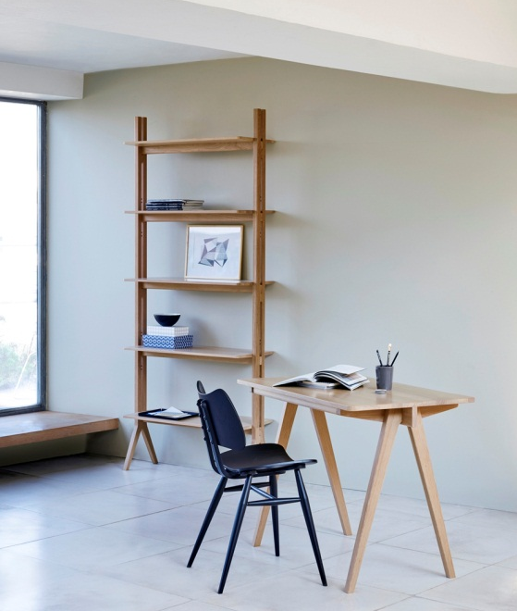 | 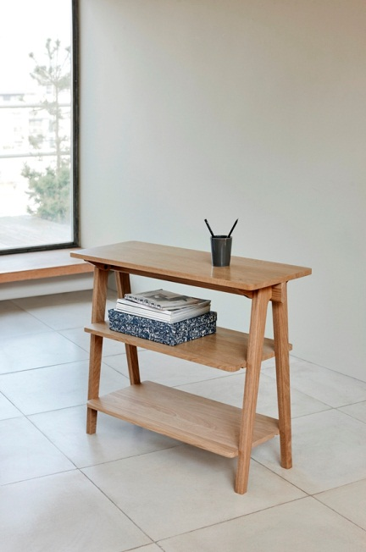
Pero Tall Shelving and Pero Desk by Matthew Hilton for ercol | Pero Low Shelving by Matthew Hilton for ercol
Flow Chair with Walnut Seat and Black Painted finish
First launched last year to international acclaim and on show at Salone del Mobile 2015 in Milan, the Flow Chair in beech was designed by Japanese architect and designer Tomoko Azumi for ercol. This May, the Flow Chair will be presented in a dramatic new way with a black painted finish and a walnut seat. The Flow Chair with Walnut Seat brings a fresh sense of modernity to the design with its curvaceous form and elegance with the use of the walnut’s rich tones with the striking steam-bent black painted frame. The high level of craftsmanship – a trademark of ercol furniture – is evident through the refined sweeping lines, tapered seat and the ergonomic stacking function that allows for space-saving.

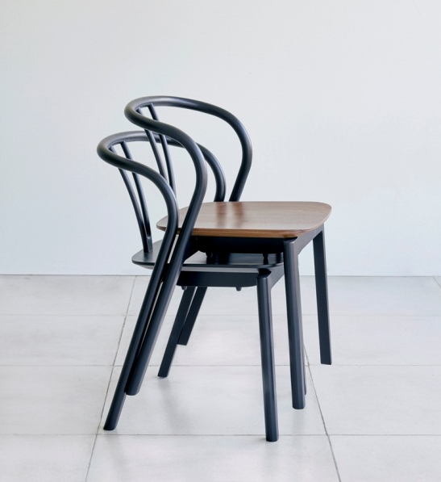
Flow Chair by Tomoko Azumi for ercol
in Black and in Black with a Walnut Seat
New interpretation of classic ercol designs
At ICFF, ercol will also present a contemporary interpretation of the Originals Room Divider (first designed by Lucian Ercolani in 1956) which has been reissued in elm and beech. The Originals Drop Leaf Table (first launched in the 1950’s) will be another classic piece on show, made in elm and beech a compact dining table ideal for urban living, has two flaps and seats four people. The Originals Bar Stool with Back in ash and beech will be on show too. These will be similar in design to the current Bar Stools but will have a back.

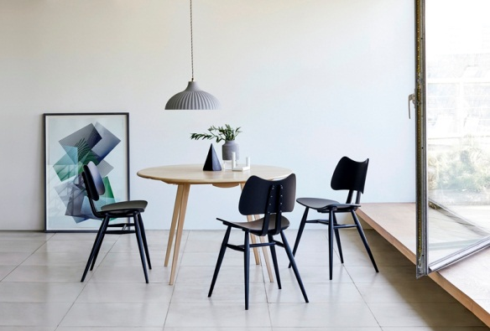
Originals Drop Leaf Table and Butterfly Chairs

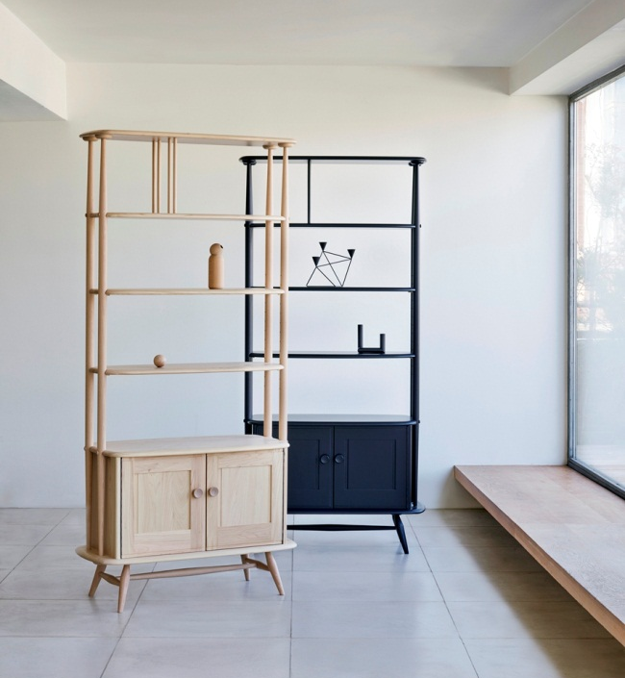 | 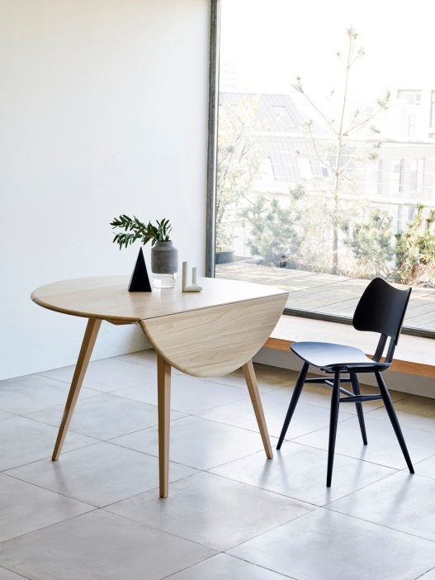
Originals Room Divider in Clear Elm and Beech  and Originals Room Divider in Black | Originals Drop Leaf Table and Butterfly Chair
Marino Sofa and Footstool
A further new design from ercol is the Marino Two-Seater Sofa and Footstool. Designed in ercol’s design studio by Dylan Freeth to complement the existing Marino Chair launched at Salone del Mobile 2015, the new Marino Sofa will share the same smooth lines – hand-crafted from steam bent solid ash – and the considered and contemporary design aesthetic. Honed from solid ash, using traditional craftsmanship and modern furniture making techniques, the firm but luxurious seat and back cushions of the Sofa and the padded Footstool will be available in 75 fabrics. The Marino Chair in Black with a new painted finish will also be on the stand.

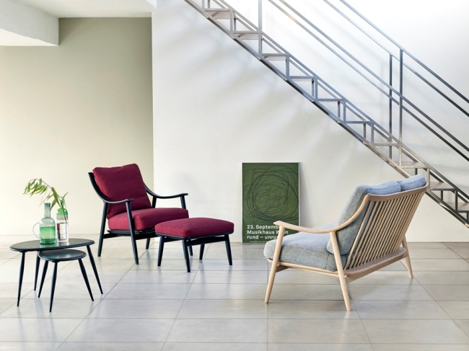
Nest of Tables, Marino Chair, Marino Footstool and Marino Two-Seater Sofa

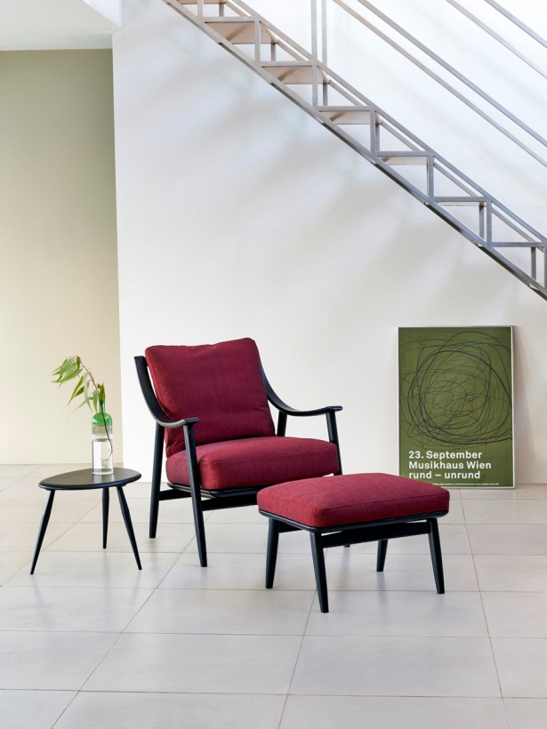 | 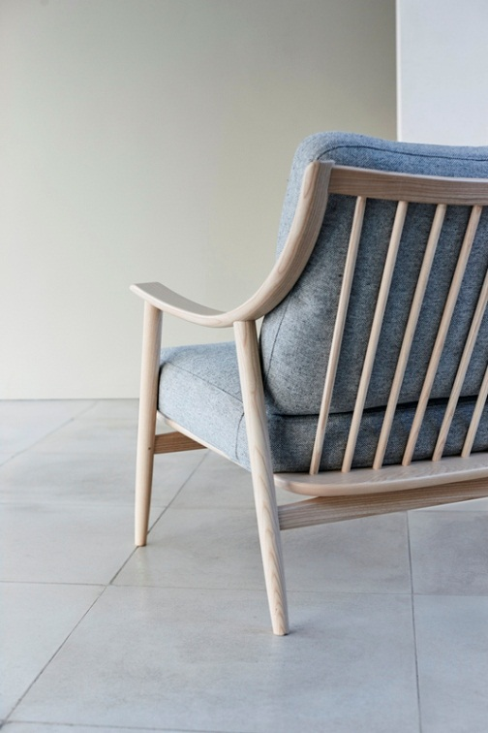
Marino Chair and Marino Footstool | Marino Two-Seater Sofa

Founded in 1920, design and craftsmanship have always been at the heart of ercol, one of England’s most enduring furniture makers. At ICFF, ercol’s stand will emphasise ercol’s sophisticated designs and heritage, its use of high-quality fabrics and rich painted finishes, and its distinguished use of beautifully crafted woods with a wonderful variety of grain that have become a signature of the company.

ercol’s Chairman, Edward Tadros, and International Sales Manager, Henry Tadros, as well as other members of the ercol team will on the stand throughout ICFF.

Stand 1648, ICFF, Javits Center

ercol collections are available from retailers throughout the UK, as well as select distributors in the US. For more details please visit the ercol website: www.ercol.com

Further information and images please contact:
Kitty Duncan / Bethan Beckett
Camron
Tel: +44 (0)20 7420 1700 / Email: ercol@camronpr.com

NOTES TO EDITORS
ercol was founded in 1920 by young Italian designer, Lucian Ercolani. In 2016 the company remains private and family-owned and today is run by Lucian’s grandson, Edward Tadros.
ercol furniture is designed and manufactured by our highly skilled workforce in our 160,000 sq. ft. purpose built factory in England.

Design and craftsmanship have always been at the heart of ercol, one of England’s most enduring furniture makers. At ICFF, ercol’s stand will emphasise ercol’s sophisticated design heritage, its use of high-quality fabrics and rich painted finishes, and distinguished use of beautiful crafted woods with wonderful variety of grain that have become a signature of the company.

ercol is very committed to growing its already successful international business in Europe, the US and the Far East with its retail and specifier partners.

