FOR IMMEDIATE RELEASE
April 11, 2016
Contact: Stephanie Seal Brown
Tel.: (502) 544-4848
Email: stephanie@stephaniesealbrown.com
Website: www.stephaniesealbrown.com
Twitter: @SSealBrown
Instagram: @StephanieSealBrown

Stephanie Seal Brown Handwovens Debuts at ICFF

Bringing Modern Design to a Craft Steeped in Tradition

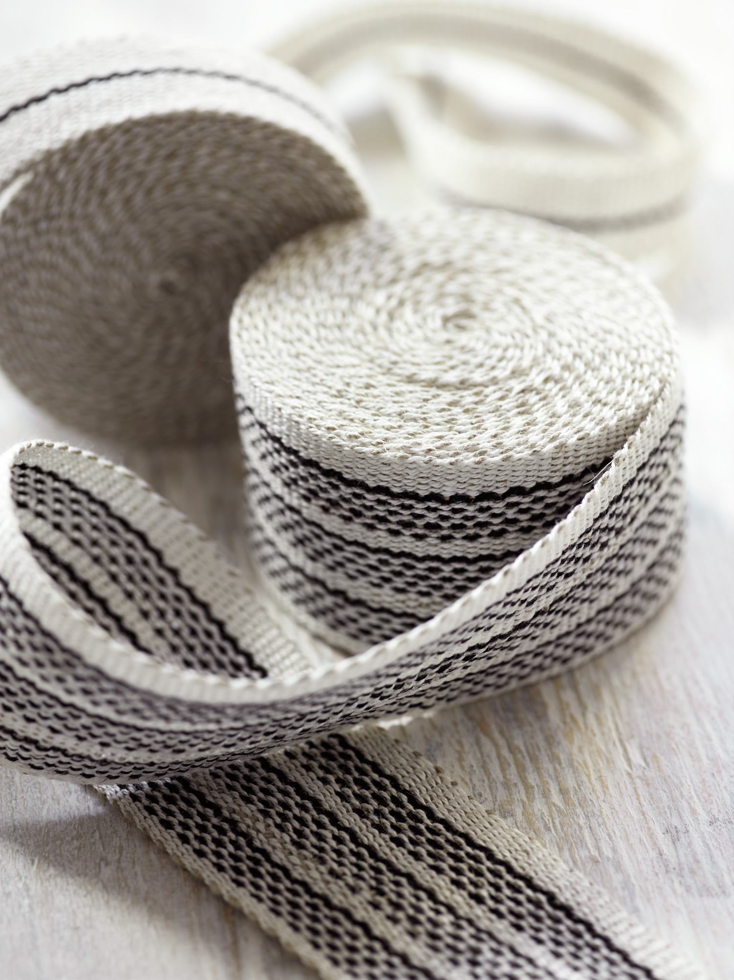
NEW YORK CITY, April 7 - Stephanie Seal Brown will release three new collections of Handwoven Linen Tape as a first time exhibitor at the International Contemporary Furniture Fair, May 14-17, 2016, at the Jacob K. Javits Convention Center. Fresh and modern, Brown’s linen tapes are designed to fill an open niche in the trim market for designers looking for clean and simple detailing.

Brown will also demonstrate weaving of her Linen and Cotton Hand Towels on a full size Swedish wooden hand loom during the show. Based on nearly 20 years experience of making and sharing handwoven towels with family and friends, her line elevates the simplest of daily tasks.

“Even with everyday household use, her pieces are designed to last for generations, and her artistry and attention to detail has made her a favorite among designers and other creatives,” Southern Living Magazine named Brown one of 2016’s 50 People Changing the South

About Stephanie Seal Brown
Stephanie Seal Brown is a New York City and Kentucky based designer/manufacturer of crisply modern, handloomed linen tape trim, and graphically distinctive cotton/linen hand towels, all woven in small batches. Her interpretation of the familiar stripe is rooted in the quiet, meditative act of weaving: bold, yet relaxed, and endowed with breathing space. The tailored designs are softened by the use of highly textural natural fibers, and a restrained palette in which strong hues are balanced with hushed neutrals. A member of the Sustainable Furnishings Council, Brown is committed to pursuing eco-friendly production, using only rapidly renewable raw materials. The finest European linen and Egyptian cotton yarns are dyed in a Swedish dye house that creates exceptionally rich colors while adhering to very high environmental standards. The linen tape trim is woven to order for design professionals, and the hand towels are available directly to consumers through her website.

For more information or to schedule an interview, contact Stephanie Seal Brown at (502) 544-4848 or stephanie@stephaniesealbrown.com.
-more-
