無為/mui “ Effortless Comfort” (ICFF2016)
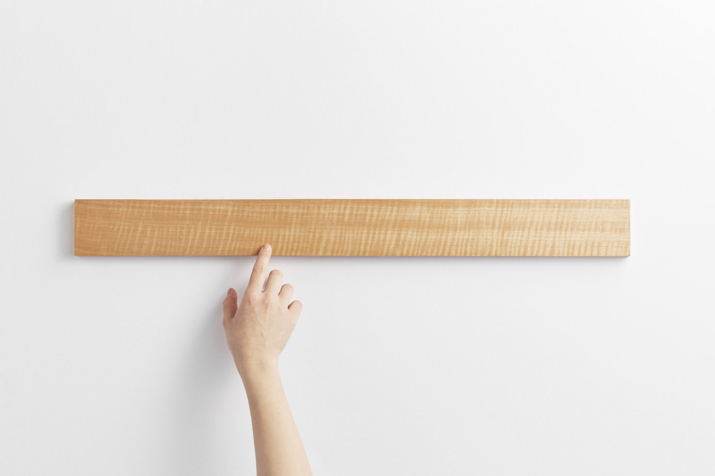
Concept:
Out of sight until needed / Out of mind until utilized
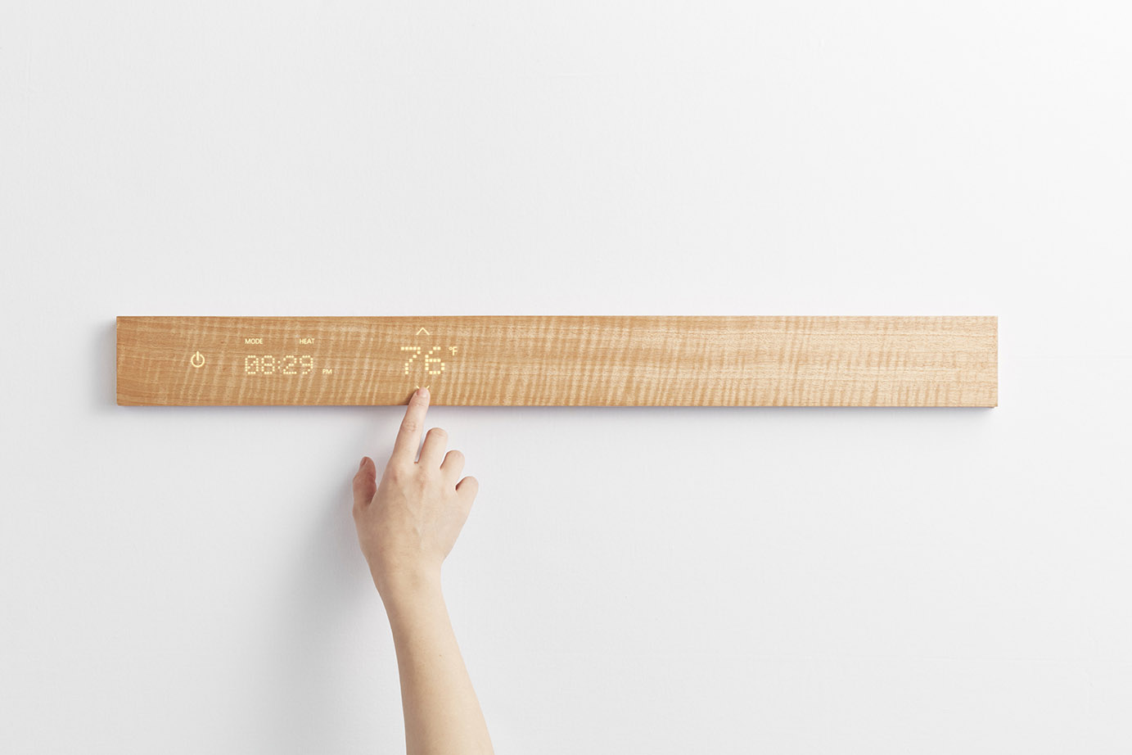
Conceptually, “mui” is a Japanese word which conveys a relaxed sense of mind and being.
“mui” is our brand for multi-functional controls designed to provide a satisfyingly enhanced user experience in areas of interior design and architectural design.

Target Market : Hospitality – Hotels-High End Residential
In every “mui” hospitality space, space understands you and adjusts your environment to alleviate stress and provide relaxation.
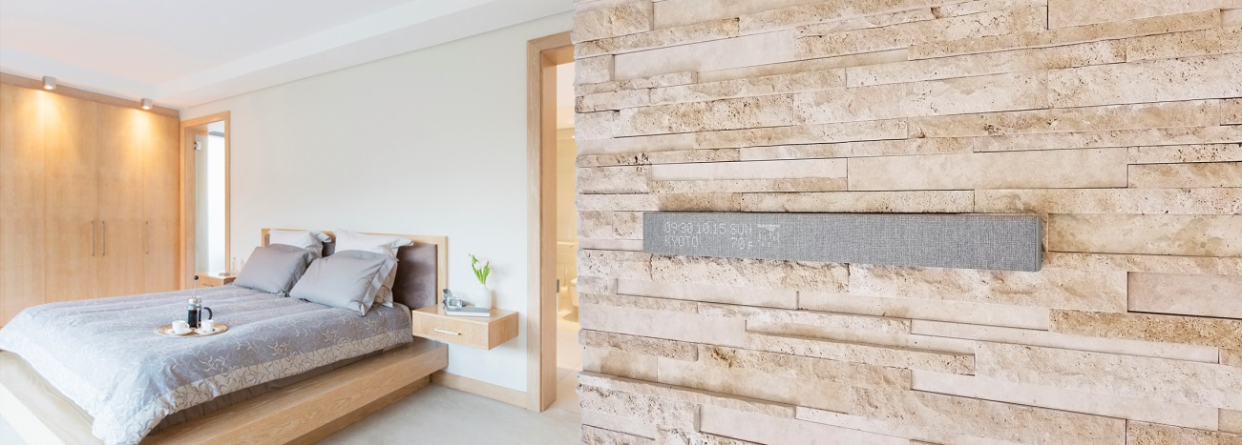
We have created a new multi-instinctive user interface that displays various features, perfectly fitted to this quality space, using the same materials.
The Thermostat and Dimmer touch sensor enables you to adjust your comfort level while displaying icons linked to various, resourceful information.
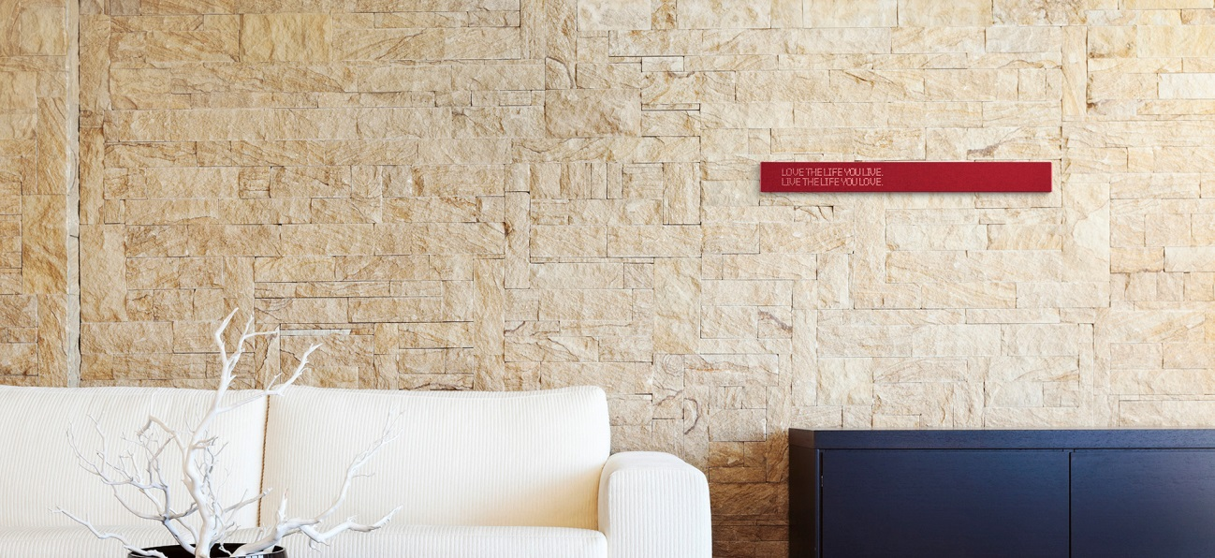
“mui”s versatile platform for aesthetics & functions
“mui” is stylistically versatile. Regarding the projection of its user-friendly interface, there are many designs from which to choose, and the projected controls work together with host of interface-surface-types. Therefore, the variations of these two factors in combination are practically limitless. In fact, the aesthetic possibilities are limited only by one’s imagination.
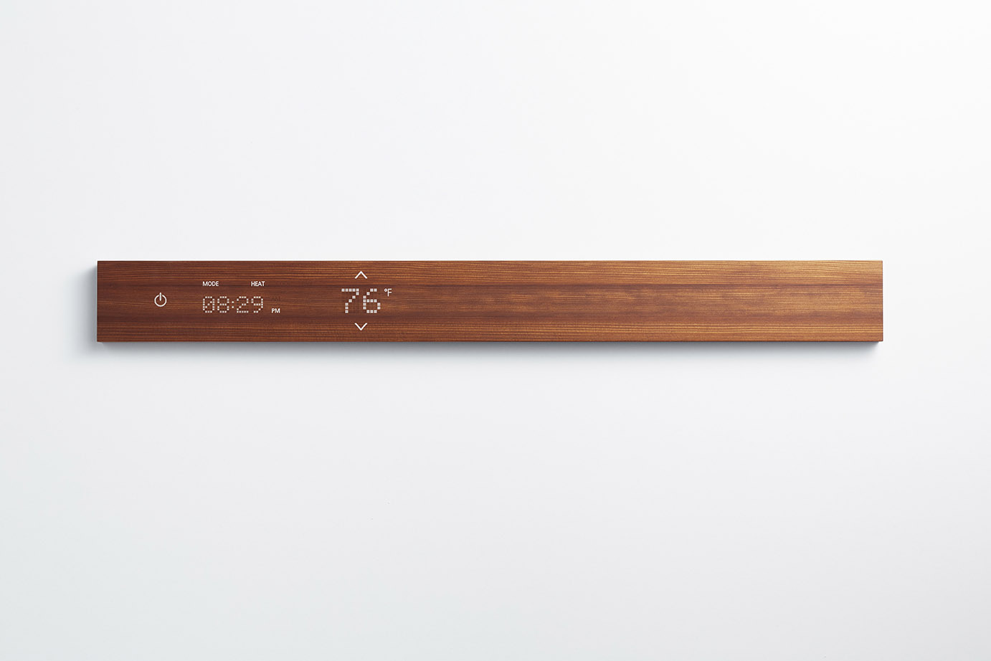
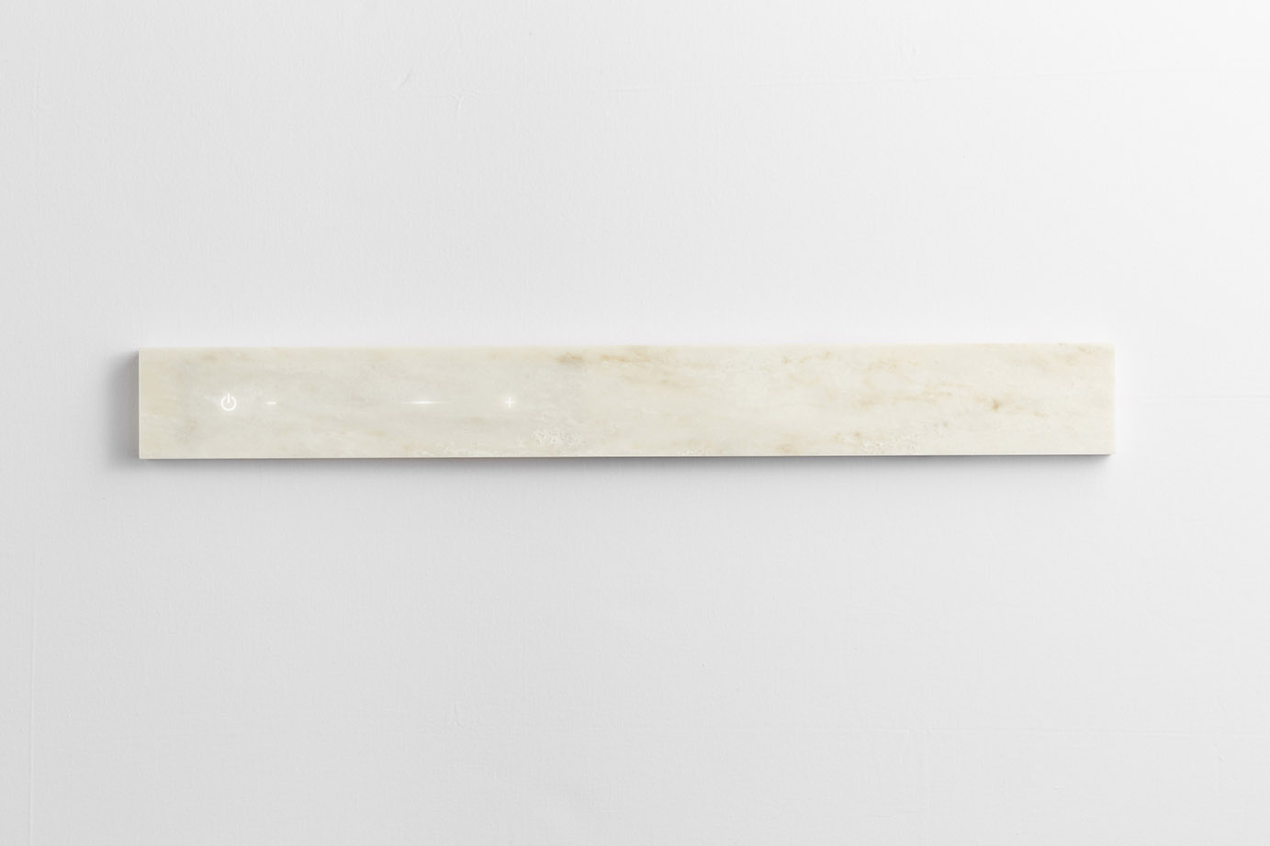
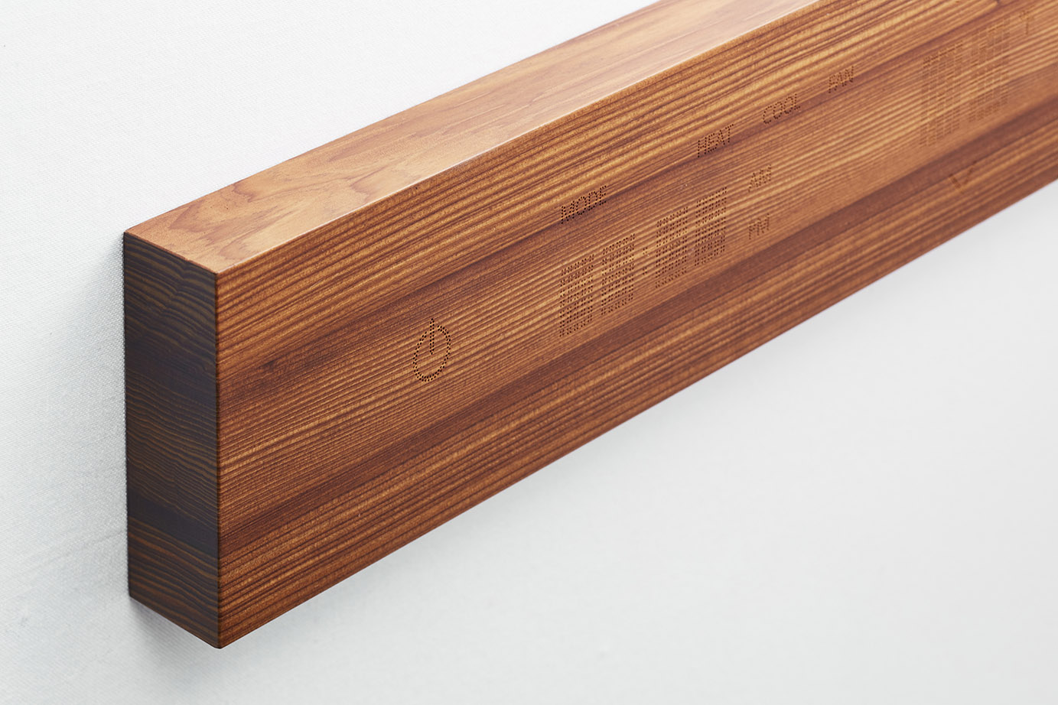
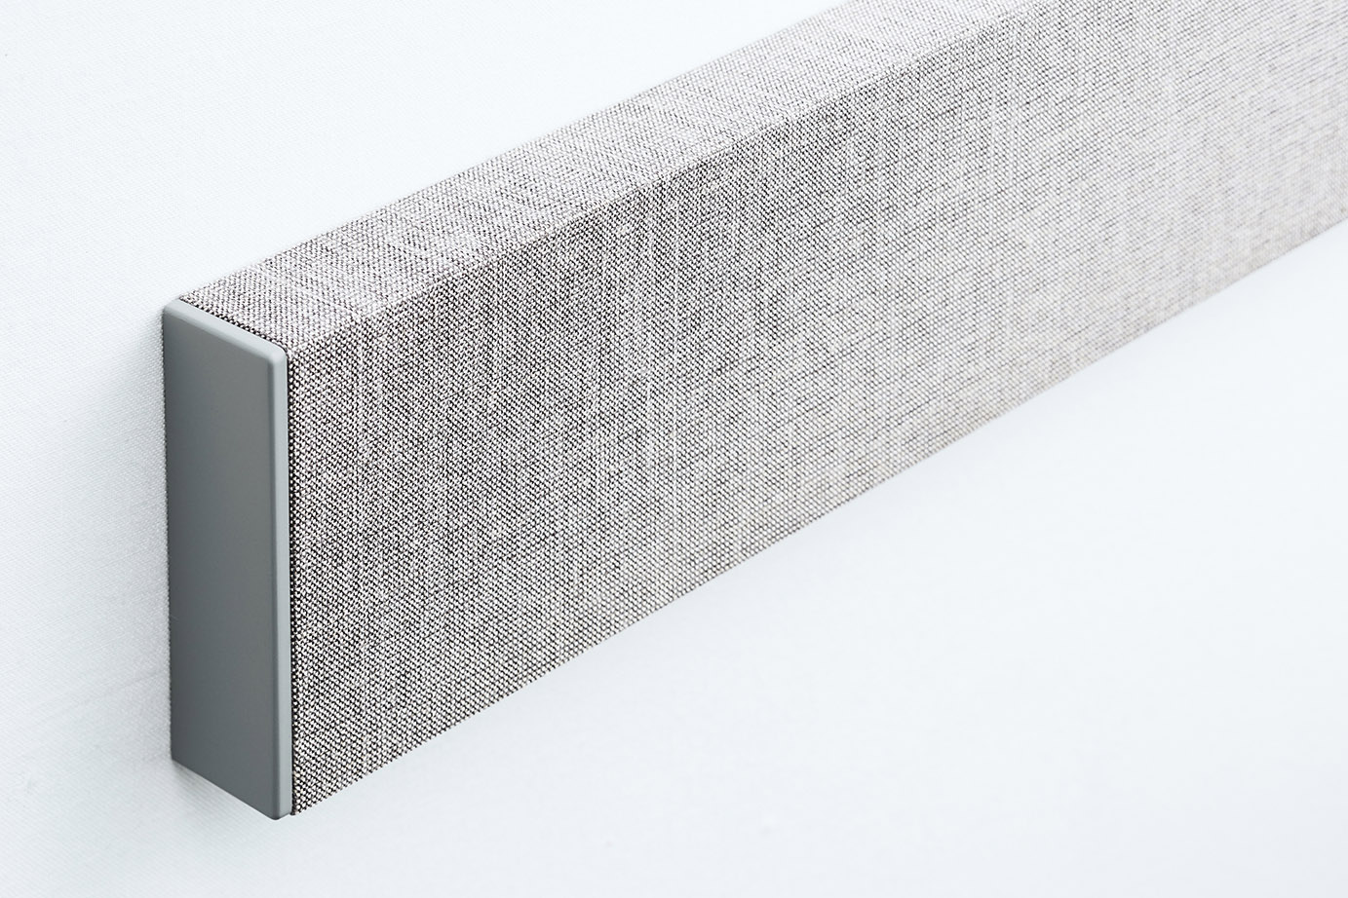
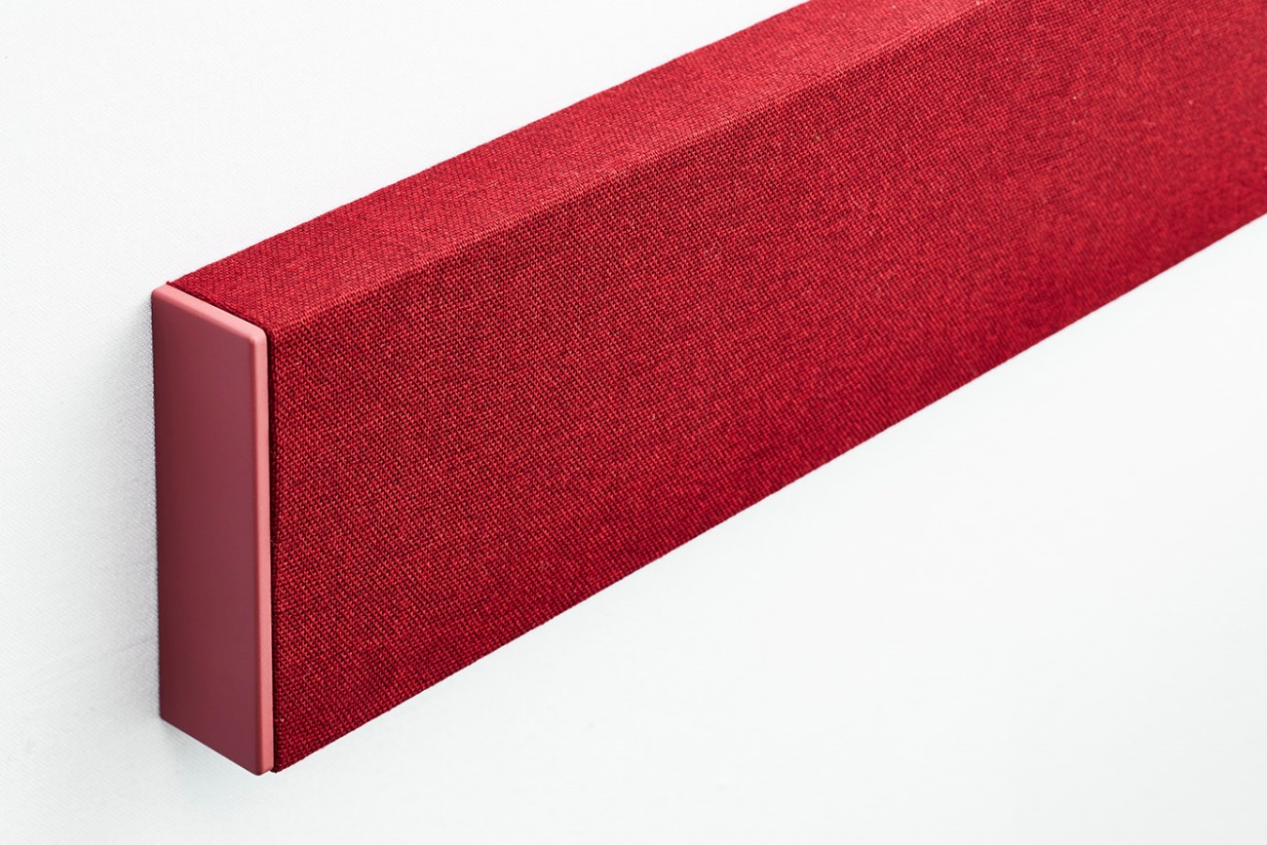
And versatile “mui” is adaptable for use with various applications and in combination with various chassis.

Company Introduction
Nissha
The Nissha company is located in the Japanese city of Kyoto, for a millennium up until the nineteenth century, the old capital city.
Since its inception Nissha has been developing technologies for innovation-driven application and products.
“mui” wall tile (launched 2015)

“mui” Wall Tile has been launched at ICFF2015 along with conception of the mui-brand aesthetic.

