Date: November 2014

Subject: If you want it, we can make it!

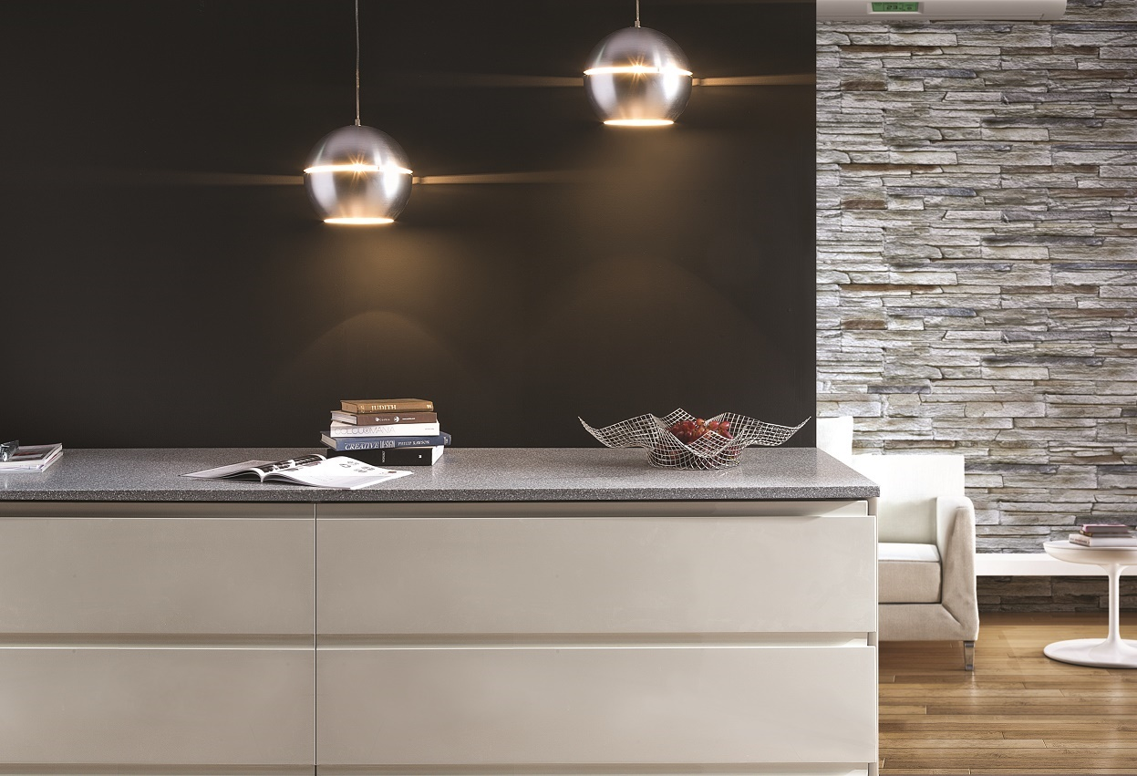

Preparing for its first visit to KBIS, Kordura Surfaces, Inc. is pulling out all the stops to ensure its product offering is bigger and better than ever. As a highly accomplished manufacturer and supplier of solid surface, hybrid solid surface and quartz surfacing materials, the company believes it will have an unrivalled range of décors and finishes on display on its booth no. S8019, located in the South Hall. The key objective of the booth is demonstrate Kordura Surfaces’ overarching philosophy, “if you want it, we can make it.”

Visitors to the booth will first encounter the extremely versatile 1 inch solid surface material which is straightforward to fabricate, easy to install, looks luxurious and is highly affordable. Solid surface is available as sheet material for onward fabrication to your specification or as an OEM countertop that is supplied factory-finished. By eliminating fabrication by a third-party, and making countertops in its own factory in China, Kordura Surfaces can help to cut cost from the supply chain.

Also on show are both ½ inch and ¼ inch solid surface sheet material. At these thicknesses, solid surface can be thermoformed allowing for 3-dimensional creations. Solid surface material is available in virtually any color of the spectrum and in a multitude of patterns and designs.

Such is the diversity of solid surface, that a number of enhancements are possible. Indeed, hybrid solid surface material from Kordura Surfaces can provide new levels of surfacing performance for hard-working residential, commercial and retail and hospitality environments. UV printed solid surface graphic panels are also available utilizing ¼ inch pure white solid surface material and printing any image of your choice. Graphic panels can be used as shower walls, table tops, backsplashes, wall art… the applications are limited only by the imagination!

One of Kordura Surfaces’ most recent product enhancements has been to develop a range of solid surface shower walls, bathtubs, direct-to-stud shower enclosures, shower bases, sinks & bowls and bathroom vanity countertops. All components are exquisitely hand-crafted, warm to the touch and available as matt, satin or gloss finishes. In addition, tub & shower wall “kits” are available in standard sizes with the components having been specially designed to fit standard enclosure sizes. The kits avoid the mess and time spent grouting associated with conventional tiling allowing for imperceptible, seamless joints.

As well as solid surface material, Kordura Surfaces is one of the world's leading manufacturers of quartz surfaces designed for high-quality kitchens and bathrooms, including countertops and sinks. Quartz surfacing materials are highly impact resistant and, as such, exceed other surfacing products such as granite and solid surface in terms of care-free performance. This resistance is achieved thanks to its natural quartz content, high performance polymers and an advanced vacuum vibro-compression manufacturing technology. On special request and subject to agreed volumes, a special anti-bacterial formula can be added to the quartz surfacing material to give additional protection for hard-working or critical residential and commercial applications.

Whether you're a builder or a developer working on a large scale residential or commercial build, the Kordura Surfaces Builder Program offers you a selected range of kitchen and bathroom products that are sold direct on a project by project basis. The program is suitable for developments between 10-1000 units where the developer/builder is seeking a “factory-finished” solution for both kitchen and bathroom products. For example, Kordura Surfaces can supply kitchen countertops, kitchen sinks, upstands and backsplashes. For the bathroom, we can supply bath and shower panels, DTS shower enclosures, vanity tops, bowls, bathtubs and vanity furniture. All components are fully factory-finished, require no fabrication and are ready to fit on-site.

With such a diverse and beautifully designed range of products on display, there is no doubt that Peter JR Holt, Vice President of Kordura Surfaces, Inc., is getting excited about the up and coming KBIS 2016 exhibition. Peter explains “I am passionate about kitchens and bathrooms and what Kordura Surfaces, Inc. can offer the industry as a whole. Our state-of-the-art manufacturing facilities give total flexibility and choice to retailers, distributors, fabricators, developers and builders throughout North America. We can fulfil custom designs to meet specific project requirements and ensure a fast and efficient response. If you want it, we can make it!”

Word count: 704

Editor’s Note

Images attached to email:
Peakstone dream set.jpg

