Vicostone adds Venatino to its marble-look collection

(DALLAS, December 2015) – Vicostone’s Collection has just been updated with new marble-look colors, available now from the company’s warehouses in Dallas, Chicago, Atlanta and Houston.
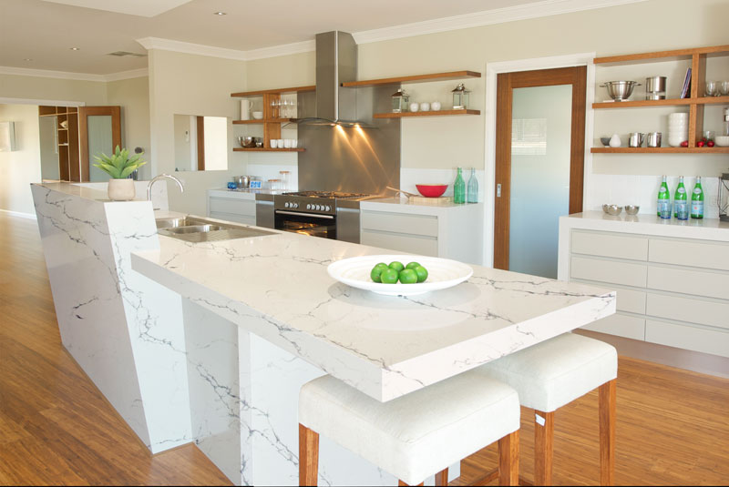

The newest addition, amazing Venatino (also known under the code name BQ8660), is a combination of Vicostone’s existing dynamically bold Borghini and elegantly subtle Statuario.

The new colors boost greater versatility of the existing collection and offer more choices for interior applications. Manufactured with Italy’s Breton technology, the new colors possess the essential characteristics that belong to quartz engineered stone such as integral solidity and strength, non-porous and color durability.

Please come to visit and take a sample of your new favorite at either of Vicostone showrooms or at our distributors’ locations, whose addresses are available on the Vicostone USA website’s section “Where to Find Vicostone”.

For addresses, hours and more information please visit http://www.vicostoneus.com and http://vicostone.houzz.com
-END-

