Peruvian Trading Company
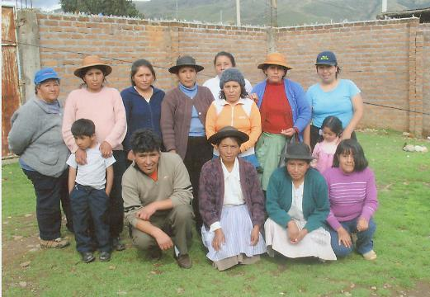
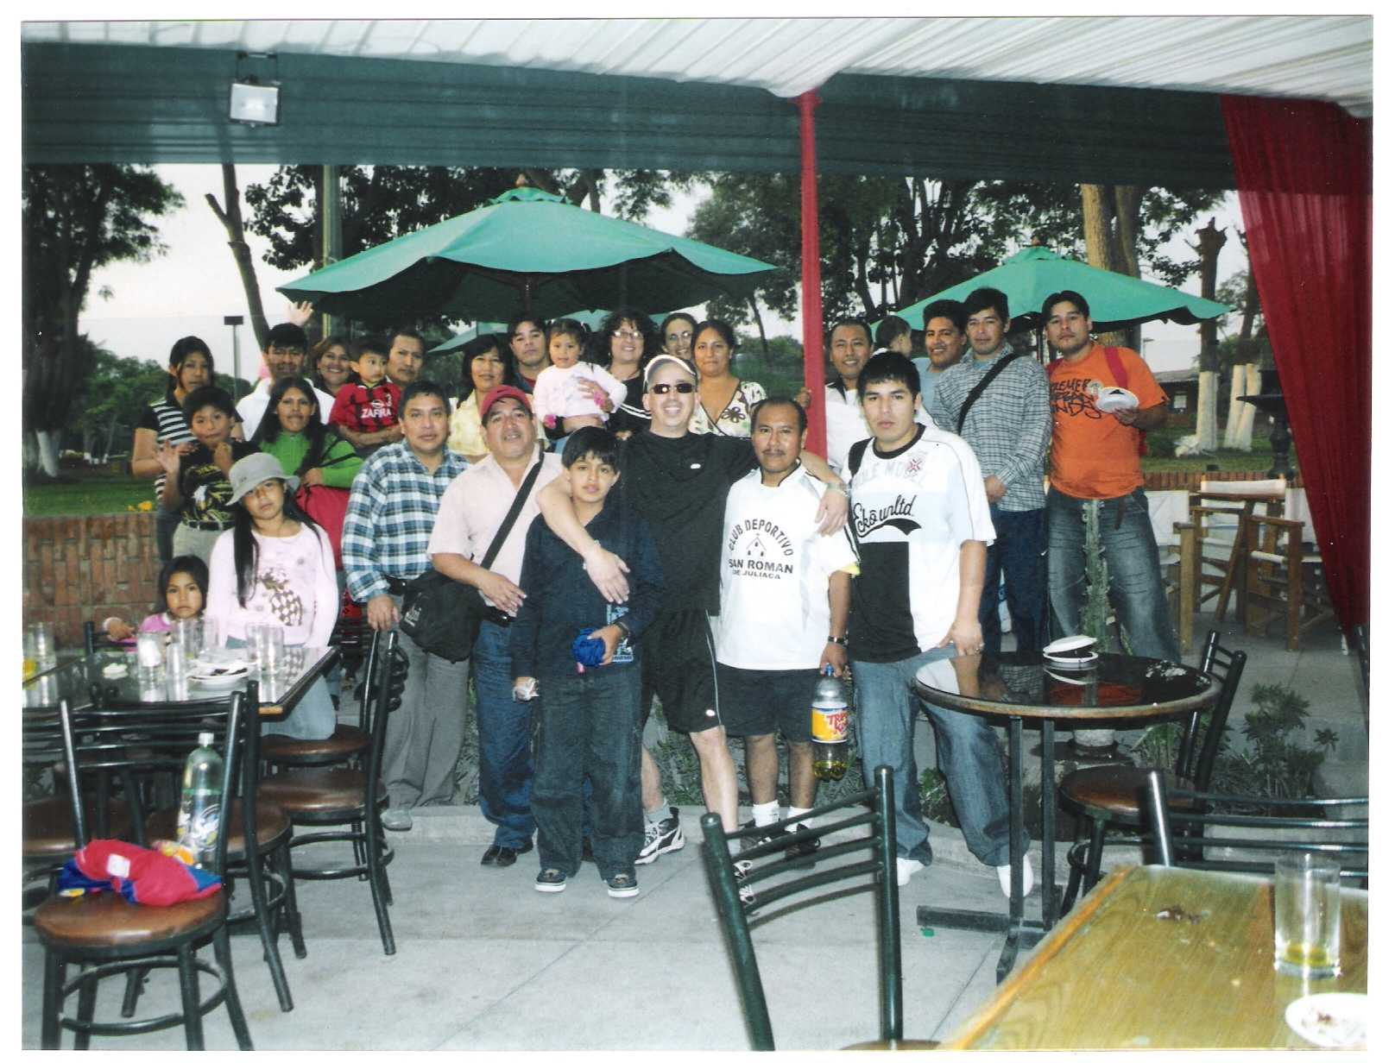
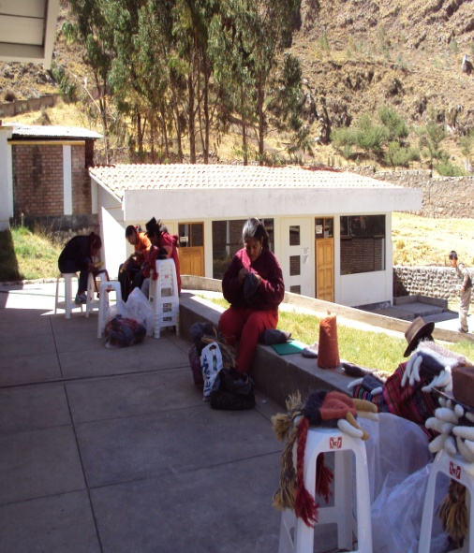
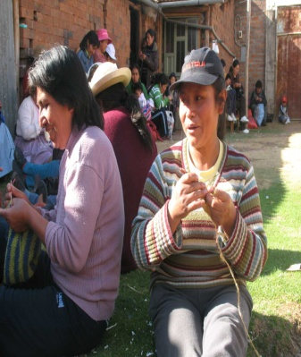
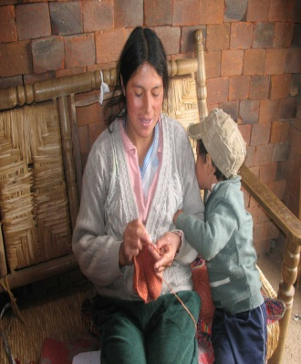
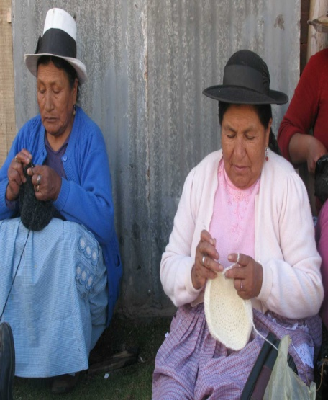
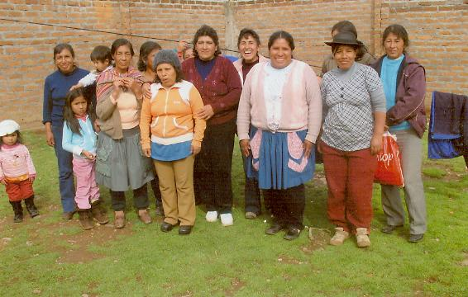
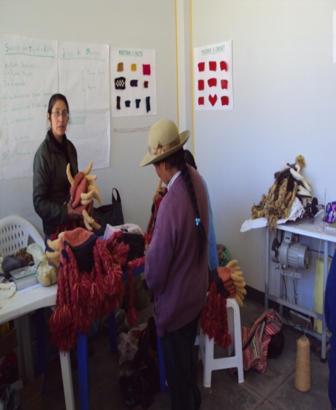
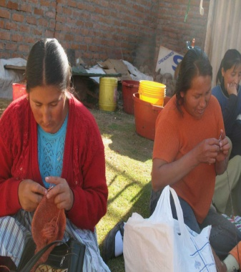
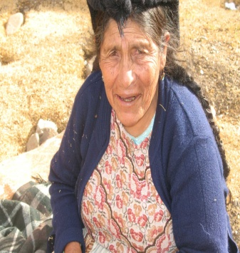
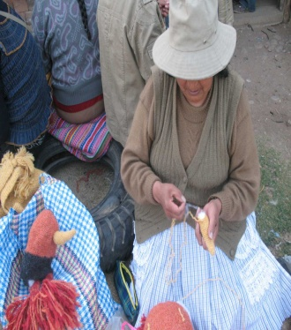
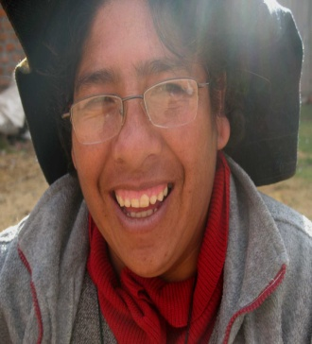
Over 20 years have passed since we first started this mutual binding economic and social endeavor.
We identified over 300 reliable and gifted knitters (mostly women) in the cities of Lima, Puno, Huancayo and Huancavelica, Peru.
They work in a cottage industry, knitting at home while caring for their families and land parcels to better themselves and to help provide to their household income.
We all make a difference in their lives when their artful labor is recognized through your purchase.
We are very grateful to all the people involved and this includes very much you; our buyer.
We traded fairly before “fair trade” was trendy.
Thank you for your business!
Patricia and Javier Dam

