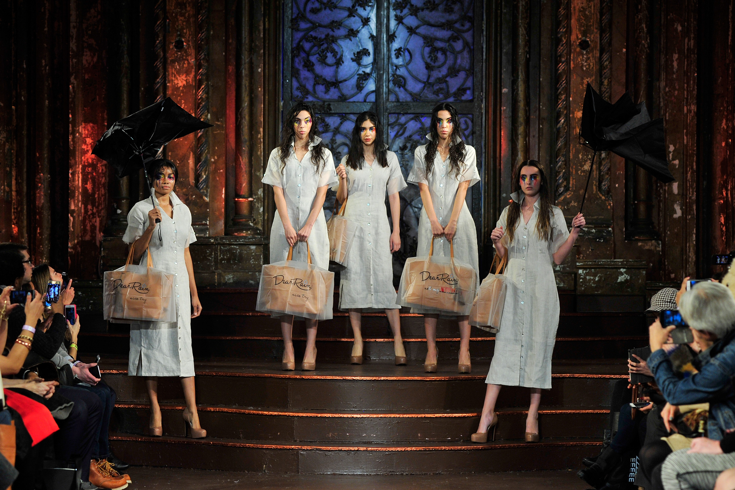
Dear Rain Takes NYFW by Storm in Debut Season
*** Link to Official Images ***
Credit: Dear Rain
New York, NY— The rainy day essential accessory for your handbag, Dear Rain made their NYFW debut this week as part of FTL MODA’s runway spectacular. Dear Rain accompanied six international designers at the historic Angel Orensanz Foundation for a compelling intermission presentation.
The designer, Daniela Ramirez, was inspired to create this line of waterproof handbag protectors after a vacation to the Gold Coast went a little wetter than expected. When rain unleashed in this always-sunny destination, Ramirez was forced to use her entire body to shelter her designer handbag. Even with the assistance of an umbrella, women are strained to leave their valuable handbags unshielded from the storm. Dear Rain’s waterproof handbag ponchos were fashioned to safeguard and prolong the life of handbags of any size and price tag.
Guests were transported this NYFW to a stormy setting for intermission at FTL MODA’s FW 2016 Runway. Haunting sounds of rolling thunder and torrential rain engulfed the space. Attendees were mesmerized as all eyes drew to the five models who paraded out to the main runway soaked from head to toe. With trickling eye makeup and terrorized umbrellas in tow, each model carried her handbag safely under a Dear Rain poncho. The designer channeled her roots by styling each model with 100% Venezuelan designs. Dresses were custom Natasha Valencia, shoes were Alepel by Adriana and handbags by Jo Aguirre.
FTL’s CEO raved "Dear Rain performance was probably the most acclaimed show, there were people in standing ovation!" Standout feedback also came from the producers at Fashion Week Online and reporters at People Magazine.
*** Link to Official Images ***
Credit: Dear Rain
About Dear Rain
Dear Rain is a line of wet weather handbag protectors made of completely waterproof materials. These one-size-fits-most handbag ponchos are the ideal solution to protect your handbags from the weather while making a fashion statement at the same time. Blending fashion and fun, Dear Rain includes a note to the rain, reminding it that the days when it could damage your handbags are long gone. Its transparent material allows you to show your beautiful handbag continually whilst keeping it safe and dry. Dear Rain’s line is proudly made in the USA and retails for 25USD.
Visit Dear Rain online at https://mydearrain.com/ , and get social by following the brand on Instagram @mydearrain and Twitter @MyDearRain . Don’t forget to like Dear Rain on Facebook!

