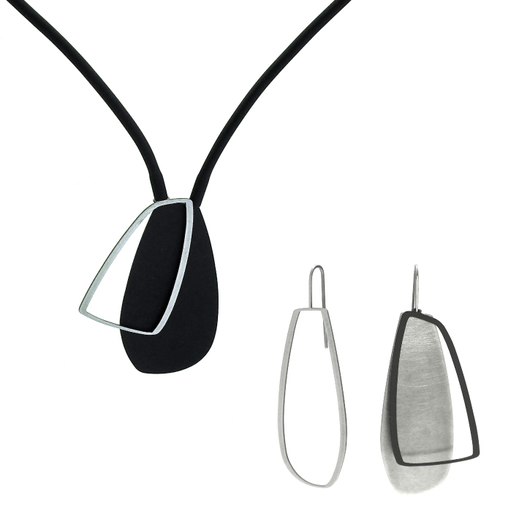
Media Release

Award-winning studio inSync design presents the X2 Collection

Interchangeable layers and clean lines describe the minimalistic aesthetics of inSync design’s new X2 Collection of earrings and necklaces.
inSync designer Iris Saar Isaacs explained the inspiration behind her latest collection.
“I created an assemblage of interchangeable fragments made from hypoallergenic stainless steel, which can be layered in black, silver and gold shapes, creating the perfect balance of restraint and surprise,” she said.
“The concept of adding, subtracting and interchanging different layers allows each piece to have several looks, keeping it fresh and interesting.”
Eight new designs have also been added to the ever-popular Line Collection, including necklaces, brooches and earrings available in this season’s luxurious colour - Pearl White - in addition to the classic raw stainless steel, 22ct matt gold plate, claret and black powder-coat finish.
inSync jewellery is designed and made in Australia in small production runs, allowing the brand to remain at the forefront of innovation and style, whilst maintaining an authentic high quality signature style.
inSync is committed to creating simple and luxurious pieces that can be worn everyday and treasured forever. Each piece is uniquely designed with meticulous attention paid to detail.

For more information about inSync design contemporary jewellery, please visit http://insyncdesign.com.au.

For further information please contact:
Iris Saar Isaacs
P – +61 416 002 027
e – iris@insyncdesign.com.au

