Contact: Barbara Rainville
802-388-0627 Release at Will
barb@maplelandmark.com

Maple Landmark to Release
New Product Line at NY Now in January.
Three Thematic Building Blocks Sets – Mission 1 Space Set,
Country Farm Set and Noah’s Ark Set to be Debuted.

MIDDLEBURY, Vt. – As a follow-up to the 20-piece Nativity Set released in August, three more thematic block sets have been developed for January’s NY Now Gift Show. Mission 1 Space, Country Farm, and Noah’s Ark sets will round out the collection and give children of all ages the opportunity to explore, build, experiment, and create their own worlds.

Most of the toys that litter this pretend play category really aren’t child-centric at all. Popular pretend play toys are often single-function, gender-biased, unimaginative pretend play, and are made from nondurable materials. However, Maple Landmark Woodcraft’s new thematic building block sets are designed to truly let the child be in charge, to pretend, and be creative!

Each of the three sets comes with 20-25 pieces of locally harvested hardwood maple that has been sanded smooth to the touch. Bright graphics are printed on one side and each piece measures 1” thick to provide stability when building, stacking and playing. The sets also come in a re-useable box for storage.
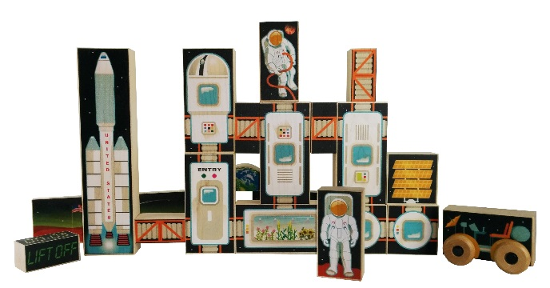
Mission 1 Space has an array of pieces that can be manipulated to create different space living scenarios. The set comes with a rocket ship, a space buggy, two astronauts, a collection of living pods – including an observatory and a garden - connecting tubes, a solar array, an earth block, and two out-of-this-world planetary landscape pieces to help set the scene.

--OVER--
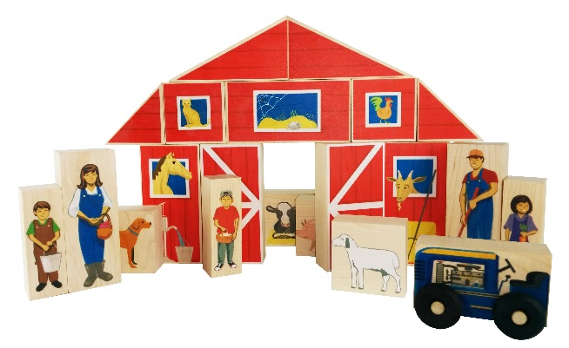
The Country Farm Set has a farm family of five, four block animals (pig, cow, sheep and dog), a tractor, and an 11-piece barn layout that can be constructed in at least six different ways. The barn is printed in a traditional barn red color with playful animals peering out the windows.

Images of the Noah’s Ark Set are embargoed until after the NY Now introduction. However, the set does includes 12 ark pieces printed with animals on one side, as well as a single block depicting Noah and his wife, and eight separate blocks showing animals two-by-two to help tell the story of Noah and the Ark.

Unlike the typical play sets that are on the market, these sets, though thematic, allow for complete open-end play – there is no right or wrong way to set up or play with the sets. These sets are also not gender biased – no pink for girls, blue for boys. The imagery is fun and kid-friendly. With all of the pieces being crafted from hardwood maple, the sets will last a lifetime. And finally, since the sets aren’t pretend kitchens, vacuums, or work benches, the experience the child has with the Maple Landmark Woodcraft sets is more worldly, explorational, educational and fun!

For more information on Maple Landmark please visit the website at www.maplelandmark.com
##END##

