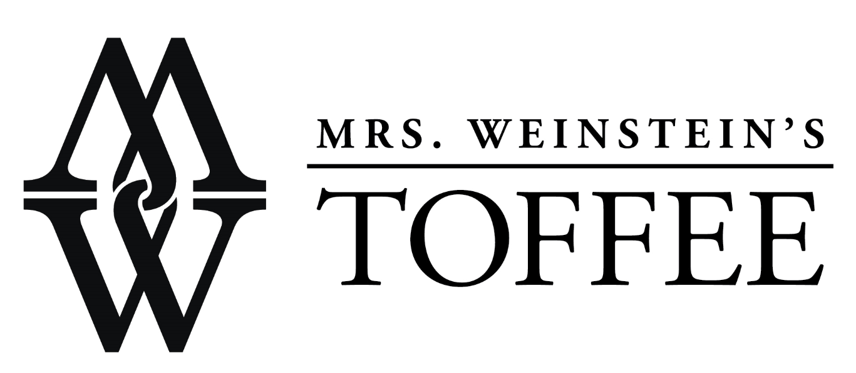
Contact:
Brandie Tobin
Marketing Manager, Sweet Shop USA
www.MWToffee.com
brandie.tobin@sweetshopusa.com
1.888.95.SWEET

Mrs. Weinstein’s Toffee Introduces New Products and Redesigned Packaging

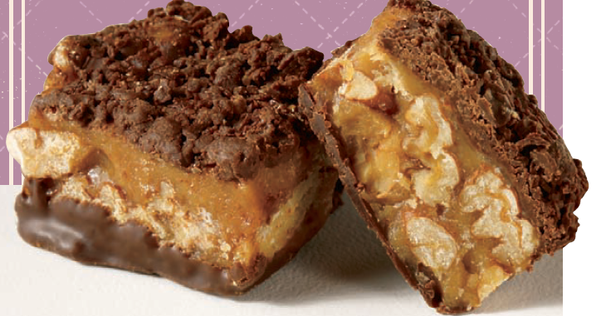
Mount Pleasant, Texas – June 2014 – Mrs. Weinstein’s Toffee announced that they will be unveiling newly updated packaging and an expanded product line for their award-winning toffee collection at the Summer Fancy Food Show held at the Javits Center from June 29 – July 1, 2014.

Popular favorites, Milk Chocolate Pecan Toffee, Milk Chocolate Almond Toffee, Dark Chocolate Pecan, and Dark Chocolate Almond Toffee have been modernized with a sophisticated new package design and new products Dark Chocolate Sea salt Toffee Squares and Sea Salt Caramel Toffee Popcorn join the Mrs. Weinstein’s Toffee product line up.

Show attendees are invited to sample Belgian White Chocolate Pecan Toffee Squares. In addition, two new popcorn varieties will be sampled – Dark Chocolate Almond Sea Salt and Cinnamon Toast Crunch Toffee Popcorn. .

Booth visitors will be able to see a “Popcorn Party” table that will illustrate how Popcorn Buffets can be incorporated into parties and events. As a fun and unique gift idea for the 2014 holiday season, Mrs. Weinstein’s is offering a unique “Popcorn Gift” made up of four mini boxes of the popcorn. The Popcorn Gifts are available to ship after July 7th, 2014.

Known by many as the “World’s Only Gourmet Toffee” and beloved by Julia Child and Former President, Bill Clinton, the award-winning Mrs. Weinstein’s toffee was founded by Mrs. Weinstein herself after she emigrated from Copenhagen, Denmark in 1964. For several decades, she created a legacy for her delicious toffee by perfecting her secret recipes and developing a loyal customer base throughout the United States. Sweet Shop USA acquired the Mrs. Weinstein’s Toffee brand in August of 2000 and held fast the commitment to provide toffee lovers with the highest quality, most decadent toffee at a reasonable price.

All-natural and made with 100% Real Chocolate, Mrs. Weinstein’s Toffee products are OU Kosher Certified and handcrafted in small batches to ensure the highest quality possible. The four signature varieties include: Milk Chocolate Pecan Toffee, Milk Chocolate Almond Toffee, Dark Chocolate Pecan, and Dark Chocolate Almond Toffee Squares, are available in 8 oz. (MSRP $14.99 to $16.99) and 16 oz. (MSRP $24.99 to $29.99) boxes. In addition to the 8 oz. and 16 oz. boxes, Mrs. Weinstein’s Dark Chocolate Sea Salt Toffee Squares and Milk Chocolate Toffee Squares are now also available in smaller snack-sized clear acetate 2 oz. boxes (MSRP $3.99).

The new Mrs. Weinstein’s Gourmet Toffee Popcorn is available in three flavors including, Sea Salt Caramel Toffee Popcorn, Original Butter Toffee Popcorn and Cinnamon Crunch Toffee Popcorn. All varieties are available in 7 oz. (MSRP $6.99).

“I have a special place in my heart for Mrs. Weinstein’s Toffee and am so excited about the new packaging and product introductions,” said Krista Webb, Chief Executive Officer of Sweet Shop USA, parent company of Mrs. Weinstein’s Toffee. “It is a fabulous product and deserves fabulous packaging, which we feel Studio MPLS has created for us. It will be exciting to watch the brand develop as we continue to expand the product line in future years.”

Mrs. Weinstein’s Toffee is available at grocery, gourmet, and specialty food retailers and online at www.MWToffee.com.

About Mrs. Weinstein’s Toffee
Since 1964, Mrs. Weinstein’s Toffee has been dedicated to manufacturing the highest quality, best tasting toffee possible. In August 2000, the brand was acquired by Sweet Shop USA, founded in Fort Worth, TX in 1972, and committed to preserving the craft of American chocolates and confectionaries. Today Sweet Shop USA carries out the Mrs. Weinstein’s commitment to quality and distributes the Mrs. Weinstein’s brand throughout the United States. For more information, please visit www.MWToffee.com and www.SweetShopUSA.com.

###

