FOR IMMEDIATE RELEASE
Contact: Francie Simpson
P: (713) 660-0577
E: Francie.simpson@frenchfarm.com
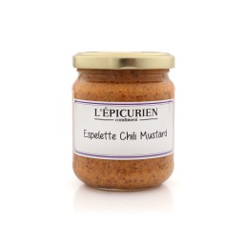
The French Farm’s L’Epicurien Espelette Chili Mustard chosen as a sofi™ Award Finalist

Houston, TX – May 25, 2016 – The French Farm’s L’Epicurien Espelette Chili Mustard has been chosen as a sofi™ Finalist for Outstanding Condiment in the Specialty Food Association’s 2016 sofi™ Award competition.
“sofi” stands for Specialty Outstanding Food Innovation and represents the best of the best from members of the Specialty Food Association. This award is a top honor in the $120.5 billion specialty food industry.
L’Epicurien Espelette Chili Mustard was one of the 100 Finalists and 28 Winners selected by a national panel of specialty food experts from more than 3,200 entries across 28 Award categories. Gisele Oriot, Founder of The French Farm, says, “We have loved this mustard for quite some time, so we are ecstatic that its exceptional flavor is being recognized.” L’Epicurien Espelette Chili Mustard can be found at www.TheFrenchFarm.com.
The French Farm was founded in 1997 by Gisele Oriot. Located in Houston, Texas, the French Farm works to bring you & your family the finest imported gourmet foods & kitchen accessories from all across Europe. Our products are carefully crafted by small, family owned businesses and are made using traditional recipes and techniques, which are handed down from one generation to the next. These products contain the highest quality ingredients and materials, have exquisite taste, and are packaged beautifully.
###

