PRESS RELEASE
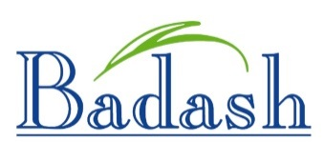

CELEBRATING OUR NEW WEBSITE

Dear Valued Customer:

Our extensive and diverse product line enables you to satisfy all of your clients’ needs. Badash highly styled and fine quality gift and home decor products are the first choice of furniture & accessory stores as well as gift shops, florists, corporate awards and recognition programs.
We pride ourselves on our continued effort to offer our customers products with unique elegance at an affordable price. Badash has strived to benefit our environment in many ways. One of which has been to shift production selection to lead free crystal which is made from all natural recyclable element minerals like potash, dolomite, sand, limestone and quartz. Badash also donates 10% of its profits to charitable causes. Jack Badash, founder of our company in 1945, would be proud!

Thanks for the opportunity to serve you!

COME SEE THE MANY NEW SUPERB GIFT IDEAS. TAKE ADVANTAGE OF OUR SHOW SPECIAL PRICING!

BADASH AT NY NOW: BOOTH 3040

VISIT OUR NEW & ENHANCED WEBSITE AT: WWW.BADASHCRYSTAL.COM

