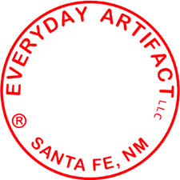

Everyday Artifact Product Information

Everyday ArtifactLLC is a collaboration of husband and wife team Jeff Ryan and Barbara Edelman, based in Santa Fe, New Mexico. We started Everyday Artifact in 1998, using art printmaking methods and materials to make objects for sale in the gift industry.

At Everyday Artifact we use a proprietary technique to apply images directly onto metal, wood and other substrates, then coat them with a jewelry resin. The result is a simple work that is rich in detail.

Our goal is to put forward imagery and words that can serve as emotional anchor points. We choose to work in black and white because it is both classic and effectively evokes memories and timelessness.

We are proud to be a 100% solar powered business.

info@everydayartifact.com

