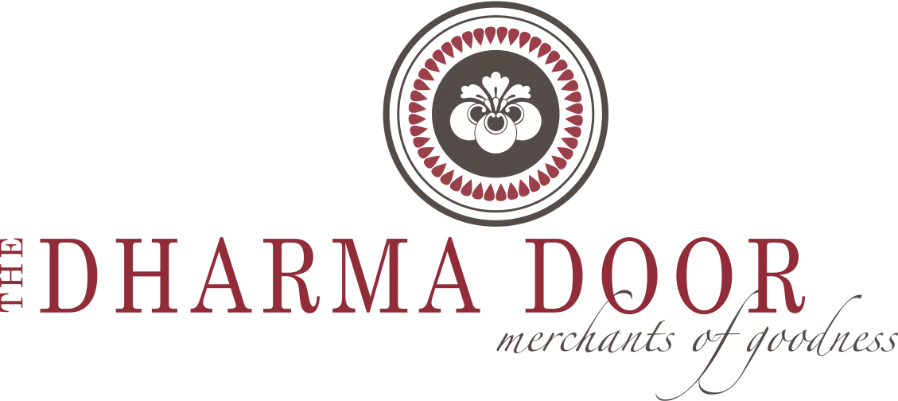

Brand History

Founded in 2004 by Australian Shannon Sheedy, The Dharma Door is where Fair Trade meets fine living. After spending a year traveling and teaching throughout Vietnam, Nepal & India, Shannon and her husband Mick followed their dream of creating products that combine good design with ethical production.

Fast-forward nearly ten years and The Dharma Door has grown to become one of the leading sources for contemporary Fair Trade and sustainable homewares throughout Australia and New Zealand. Building their relationships with producer partners and artisans, as well as a network of wholesale and retail clients, they next set their sights on expanding the brand to the US market.

William & Katie Berg first met Shannon & Mick on a bus ride in Vietnam in early 2003. Friendship took root in youthful travel and over the years has grown to include a new business venture, bringing this gorgeous brand to the North American marketplace. Drawing on their backgrounds in French antiques and film production, they bring a unique set of skills to the table. Launched in the spring of 2014, The Dharma Door USA has exceeded all expectations. The first shipment of goods sold out in just a few weeks time. Growing steadily over the next several months, the response from customers across the country has been amazing.

The Dharma Door products are made by hand using traditional techniques in modern forms. All of the artisans work within Fair Trade groups focusing on providing healthcare, education and fair wages. Every item produced is beautifully designed and impeccably crafted - each stitch & fiber tells a story.

It is the mission of The Dharma Door to bring Fair Trade goods to a new marketplace, bridging the gap between ethical production and contemporary style. We believe that our choices as consumers make a difference in the world, from the food we buy, to the products we use & love in our home, small actions lead to big change.

