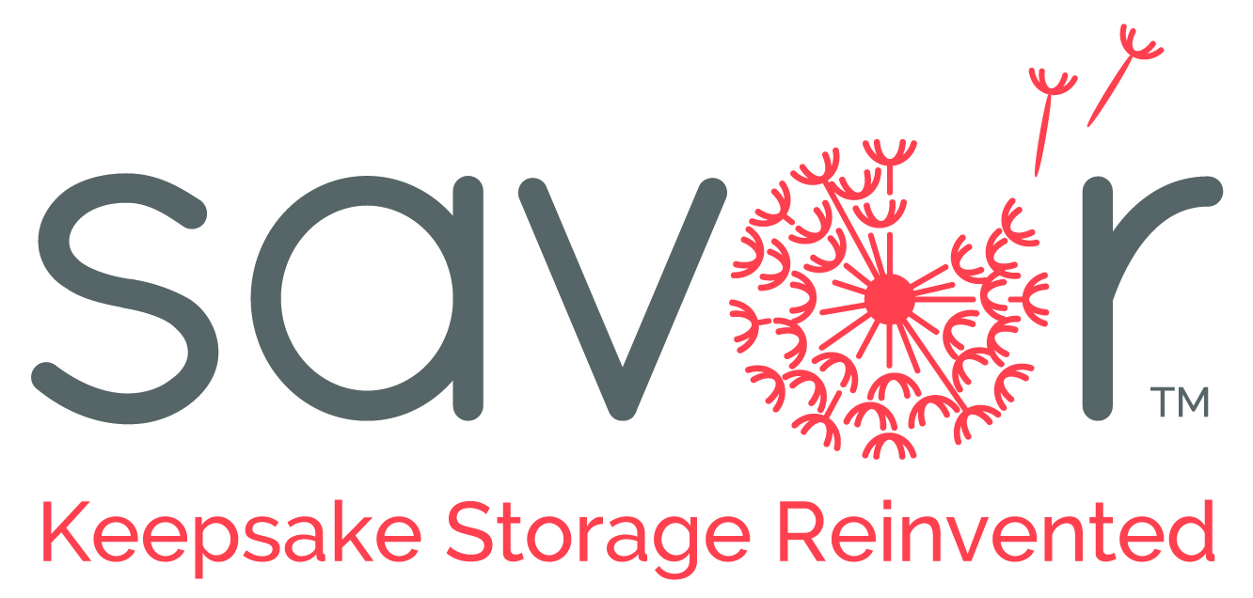 MEDIA RELEASE
June 10, 2016

Contact: Jennifer Nevins, jenny@savor.us 646-872-4196
Karla the Losen, karla@savor.us 917-696-0508

Introducing new “go to” baby gift: Savor’s Keepsake Boxes
for Modern Parents
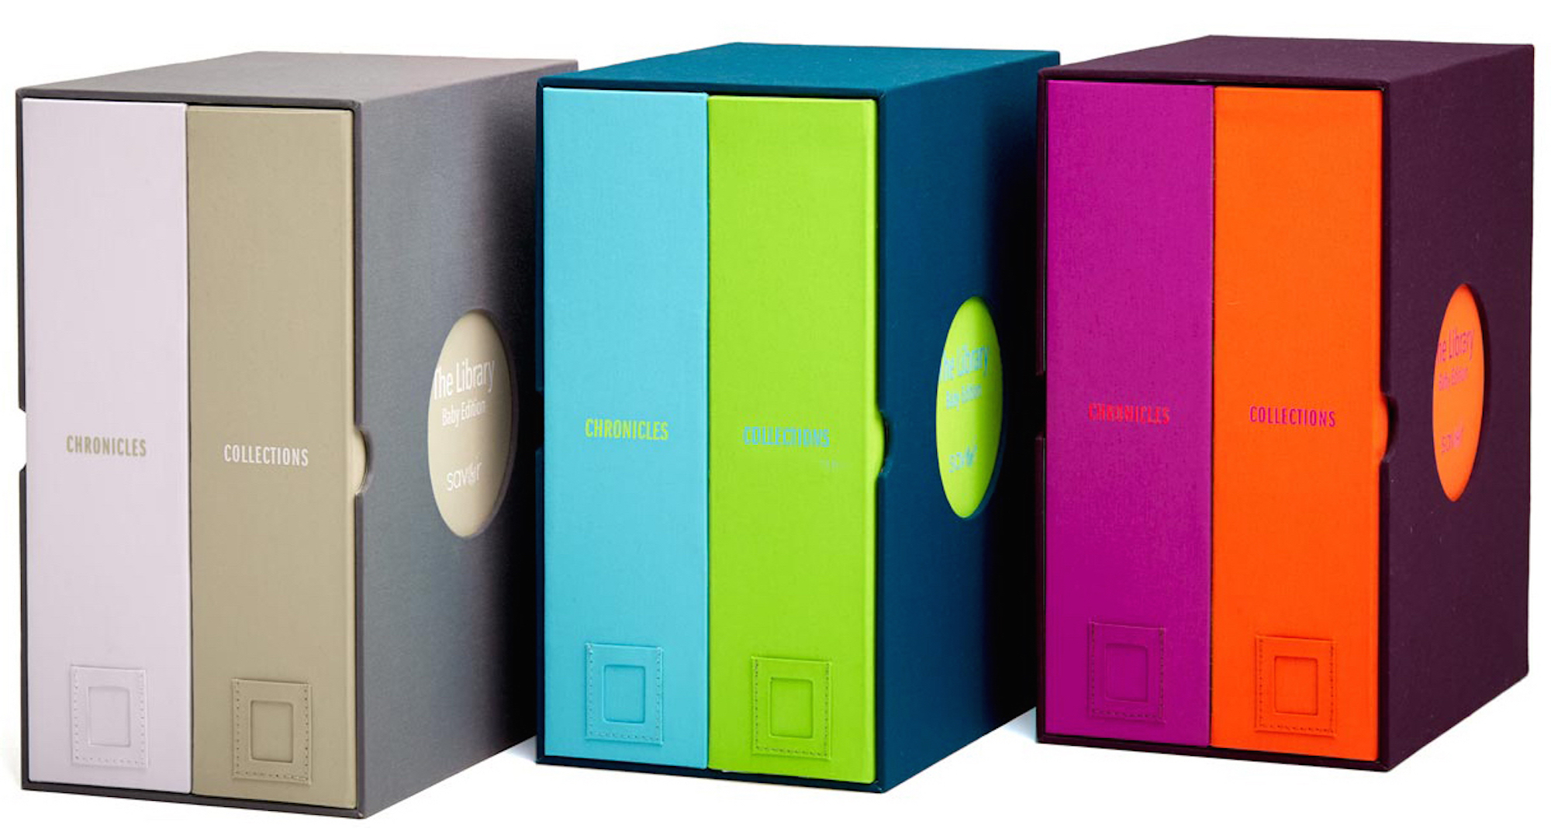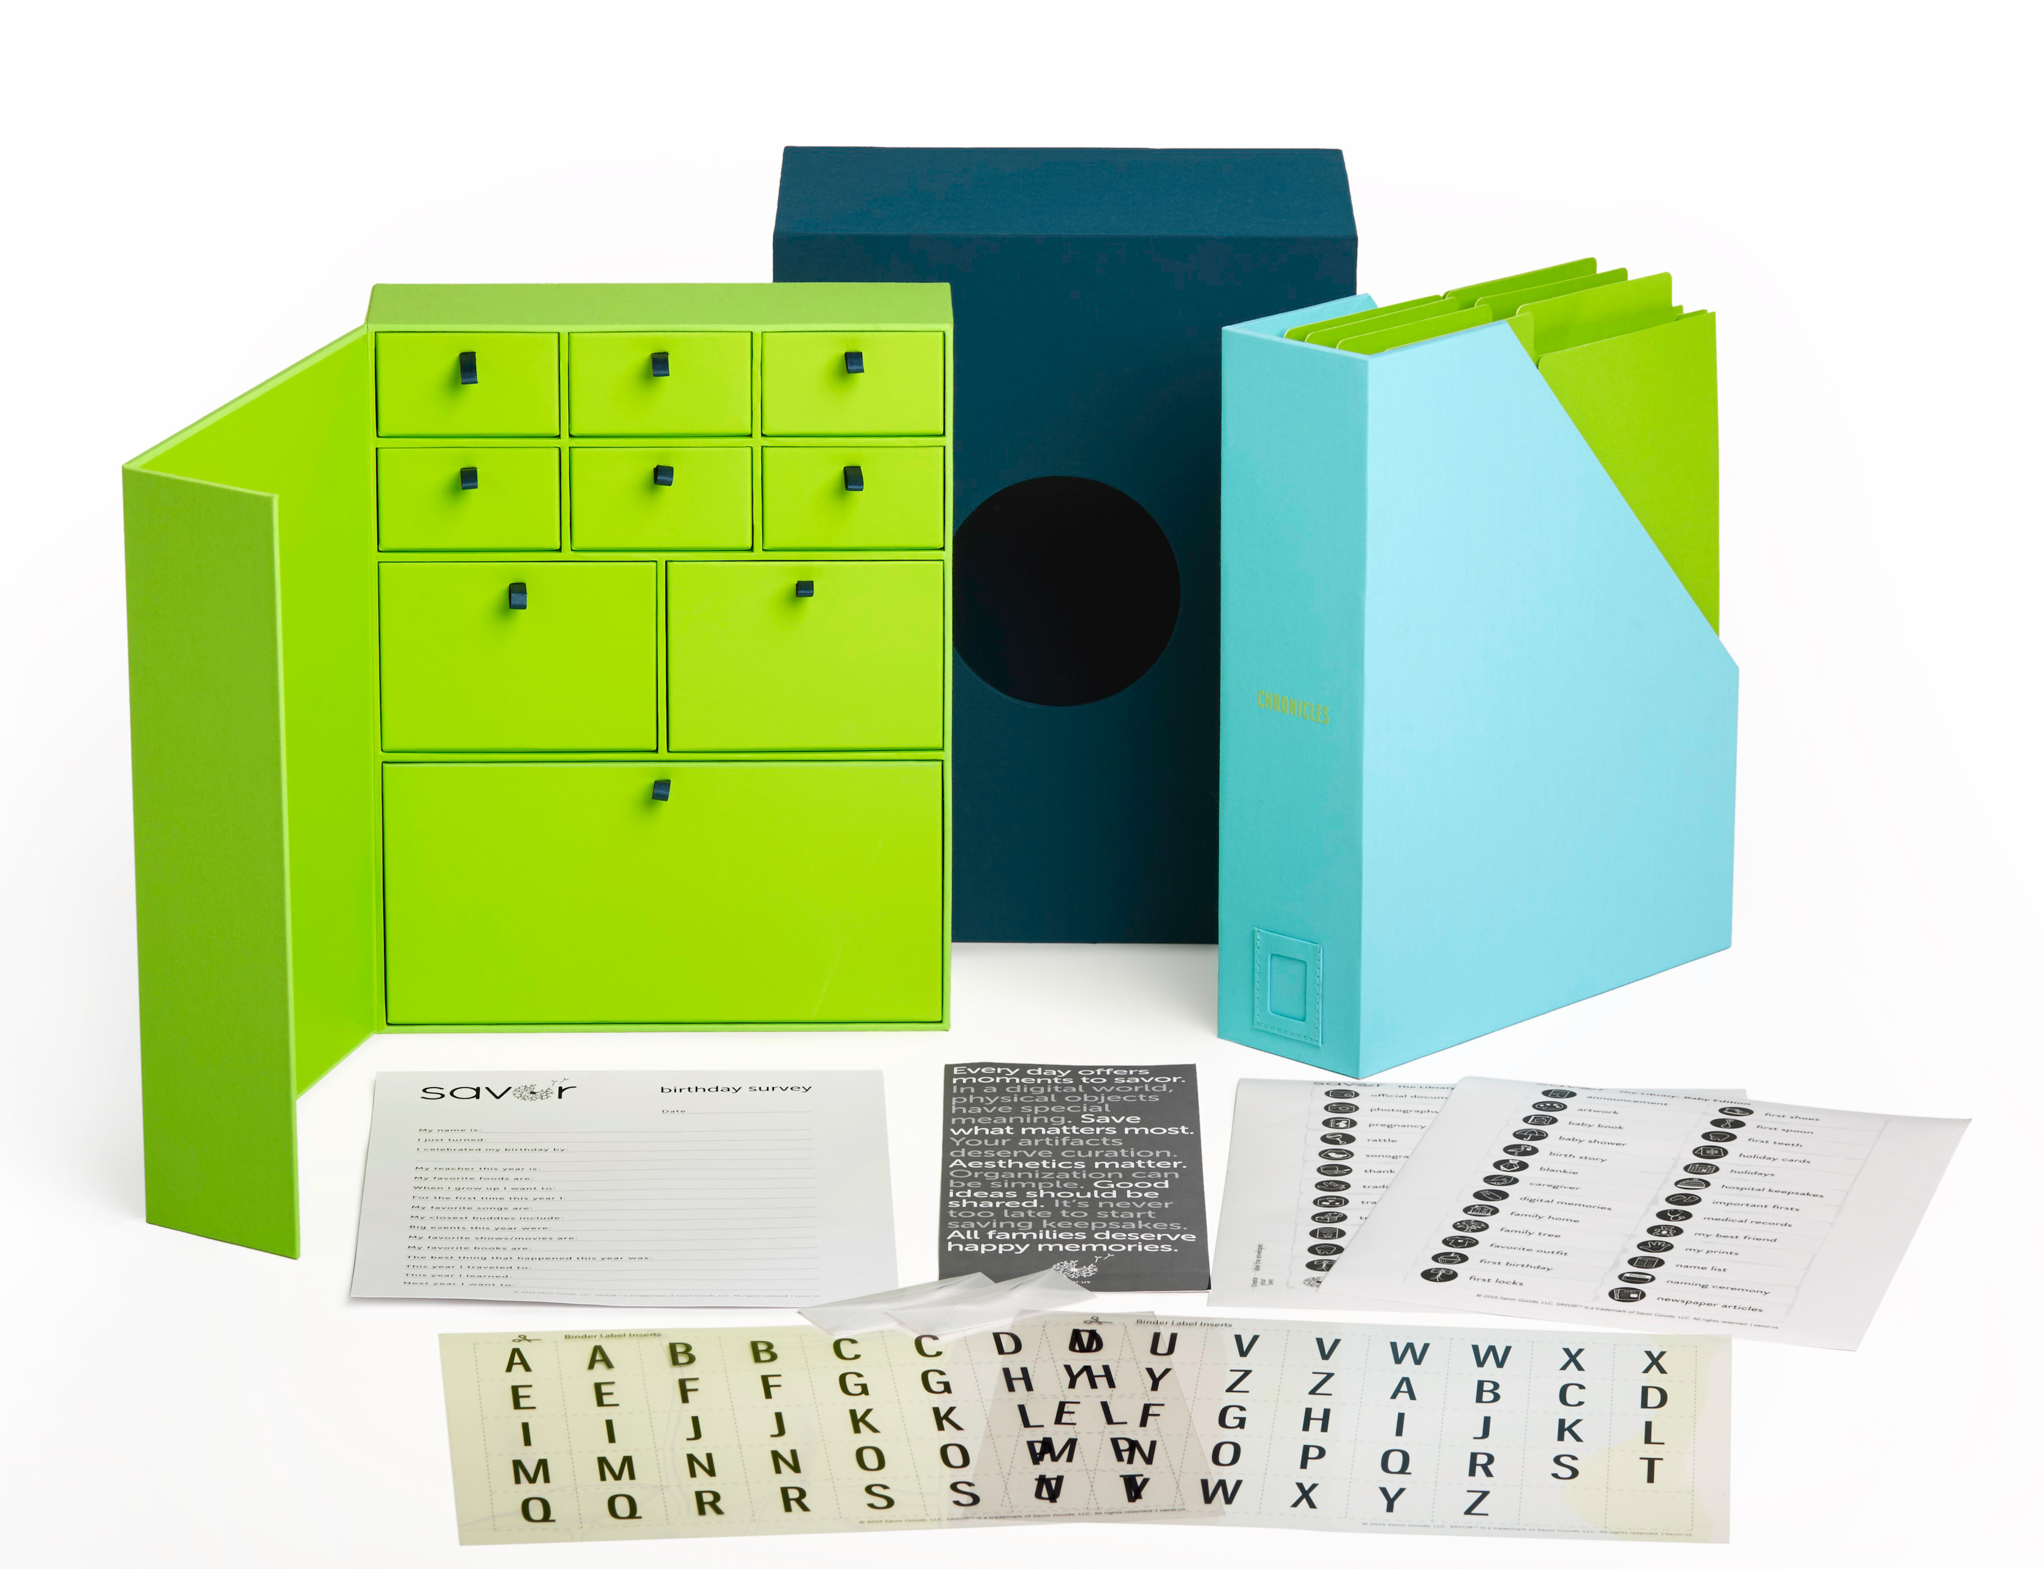

Savor is thrilled to introduce its first product line, The Library, at the AmericasMart gift show in Atlanta, July 14-18, 2016, Booth. The Library is reinventing keepsake storage for modern families. At Savor we believe our mementos tell our stories, and they deserve a box as special as they are.
For many of us, our treasured keepsakes get relegated to an ugly plastic bin at the top of the closet: ignored, disorganized, and ultimately lost. Savor has developed a better, easier way for organizing these childhood treasures, beginning with the Baby Edition (for ages 0-4) and the School Years Edition (for ages 4+). Savor’s handmade, book-cloth covered boxes resemble coffee table books and fit with modern décor, so they are kept accessible, to make looking at them or adding new items simple. The paper is acid free, so items are protected. And the more than 50 labels take all the thought out of organizing family memories. Just peel a sticker, drop in a memento, and enjoy!
Savor co-Founder Karla the Losen says, “As parents ourselves, we knew that parents wanted a solution for preserving childhood mementos that was simpler and more beautiful than the plastic tub or baby book.” She adds, “We should be able to talk about our family’s precious memories without feeling guilty or angst ridden.”
“Customers have told us that The Library is their new ‘go to’ baby gift,” notes Savor co-Founder Jennifer McAllister-Nevins. “When keepsakes are organized and accessible, families love looking through them,” says McAllister-Nevins. “It’s the difference between pictures that just sit on your computer and the photo book on the table that gets enjoyed again and again.”
The details were important to solve this problem, so the Savor founders (friends since their daughters started pre-school together 9 years ago) took their time in developing the product. “We spent over two years researching the Library and interviewing everyone -- parents, grandparents, retailers, designers, archivists, organizers, and others -- about what they wanted,” the Losen states. “The Library, a premium, more impactful keepsake product, is the result.”
The Library retails for $80 for the Baby Edition and $70 for the School Years Edition. It is available for purchase from savor.us. It is also available at boutique retailers such as Genius Jones (Miami), Babesta (New York) and Magic Beans (Boston). Online retailers include: BuyBuyBaby.com, Grommet and Uncommon Goods.
Each edition includes:

- Handcrafted, book cloth case
- 50+ illustrated pre-categorized labels
- 9 individual drawers hold objects from blankie to baby shoes (School Years has additional 8 vertical files)
- 8 vertical files hold important documents and photos
- Acid-free lining
- Acetate Initials for personalization
- 2 Envelopes for small keepsakes
- Birthday Survey to document yearly highlights

