ANNIEGLASS ANNOUNCES
NEW METALLIC GLASS LINE &
WINTER 2016 COLLECTIONS

Watsonville, CA – May 25, 2016 – Annieglass, the handcrafted American luxury tabletop serveware from internationally renowned California artist Annie Morhauser, today announces the release of its Winter 2016 Collection and the introduction of the new line Mod. The Annieglass Winter 2016 Collection is designed to evoke heartfelt warmth among family and friends and appreciation for the art of small batch craft. The Winter 2016 Collection satisfies both elegant entertaining and the growing trend called “grazing”, where guests sample an array of hearty appetizers and side dishes.

Annieglass celebrates 33 years of integrity and devotion to American craft and the ancient process of glass slumping, rendering each piece a unique work of art. Versatile and durable, Annieglass luxury tableware is utilized by restaurants and resorts throughout the country, can withstand the dishwasher, and is sustainably handcrafted in California’s Central Coast. Annieglass retains its natural textures from the handmade ceramic molds and as a personal touch, showcases a hand-engraved signature on the back of each piece. Annieglass has earned a permanent place in the Smithsonian Museum of American Art, in the Gallery of Modern Art, Glasgow, Scotland, and at the Corning Museum of Glass. Annieglass is available at nationwide luxury retailers including Bloomingdale’s and Nieman Marcus. As a testament to its artistry, Annieglass can be found on the tabletops of famed Silicon Valley restaurant, Manresa, owned by Michelin 2-star chef, David Kinch.

Fulfilling the need for a fresh, contemporary interpretation, the newly created Mod line is a youthful departure from traditional Annieglass pieces. As some of her favorites in the Winter 2016 Collection, these new Mod ovals look as if they have literally been dipped in 24k gold
or genuine platinum. The variation between the muted glass and shiny precious metals
radiates sparkle.

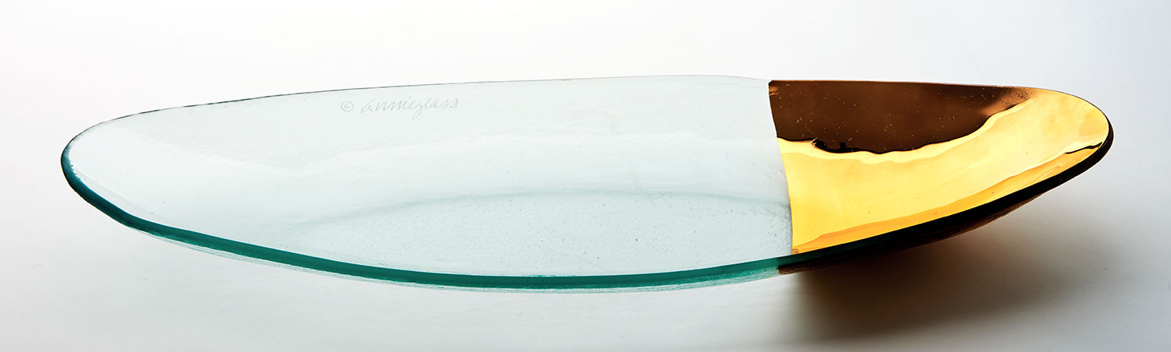
Each piece in the Winter 2016 Collection offers an exquisite frame for both opulent entertaining and casual gatherings.

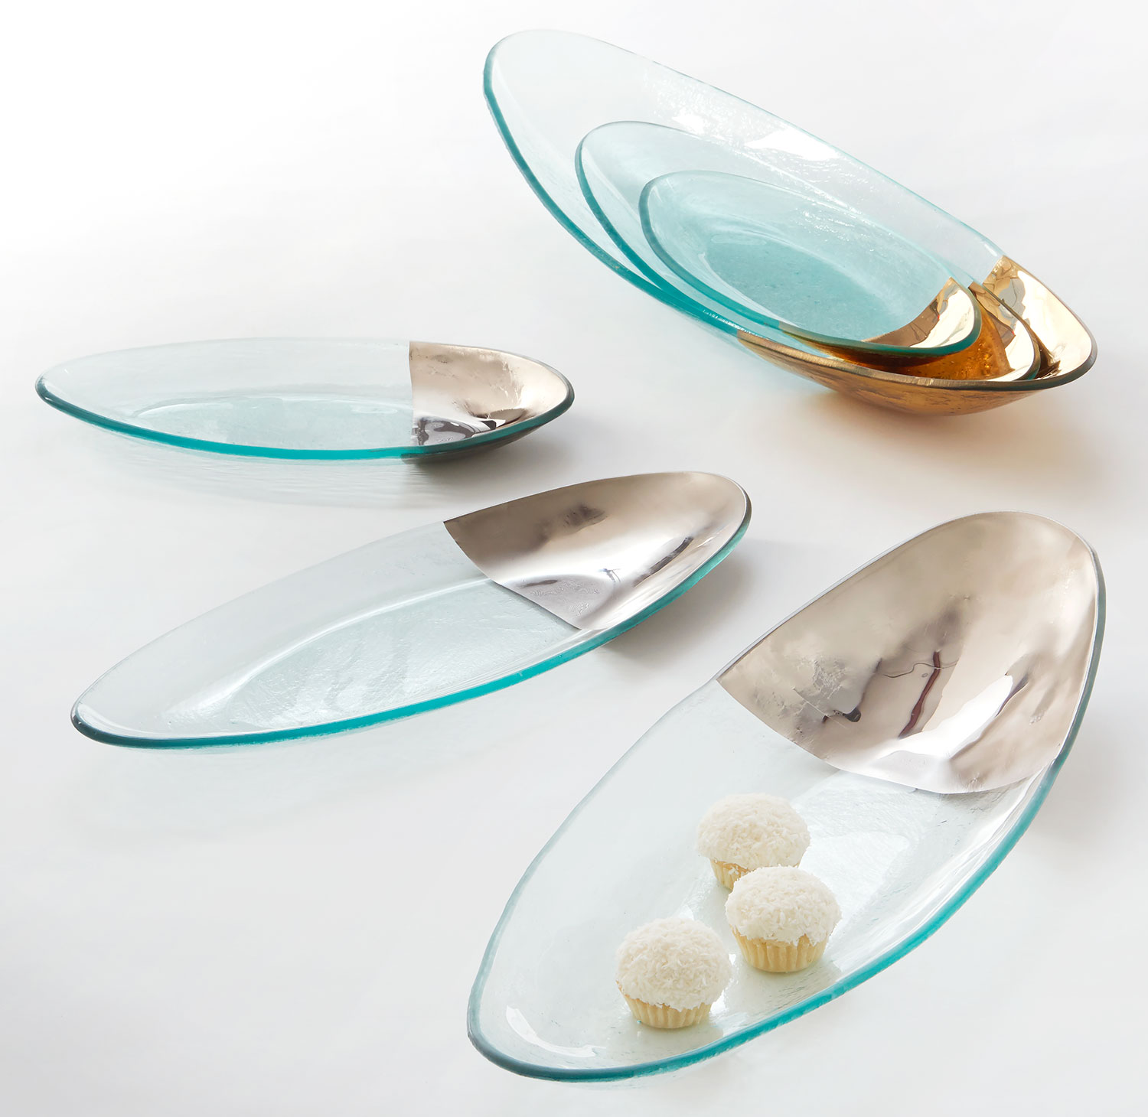

MOD SMALL, MEDIUM, AND LARGE OVAL SERVERS
Forever experimenting, Annie’s newest line Mod is a modern, Dutch-inspired design showcasing rounded edges that appear to be dipped in precious metals. Mod introduces a Small Oval Server
5.5 x 11.5”, Medium Oval Server 6 x 16.5”, and Large Oval Server 8 x 22.25” with each piece available in either 24k gold or genuine platinum-tipped styles. Just right for casual grazing – for parties of two and large crowds alike. MD150G or P is $103, MD151G or P is $147, MD152G or P is $193 MSRP.

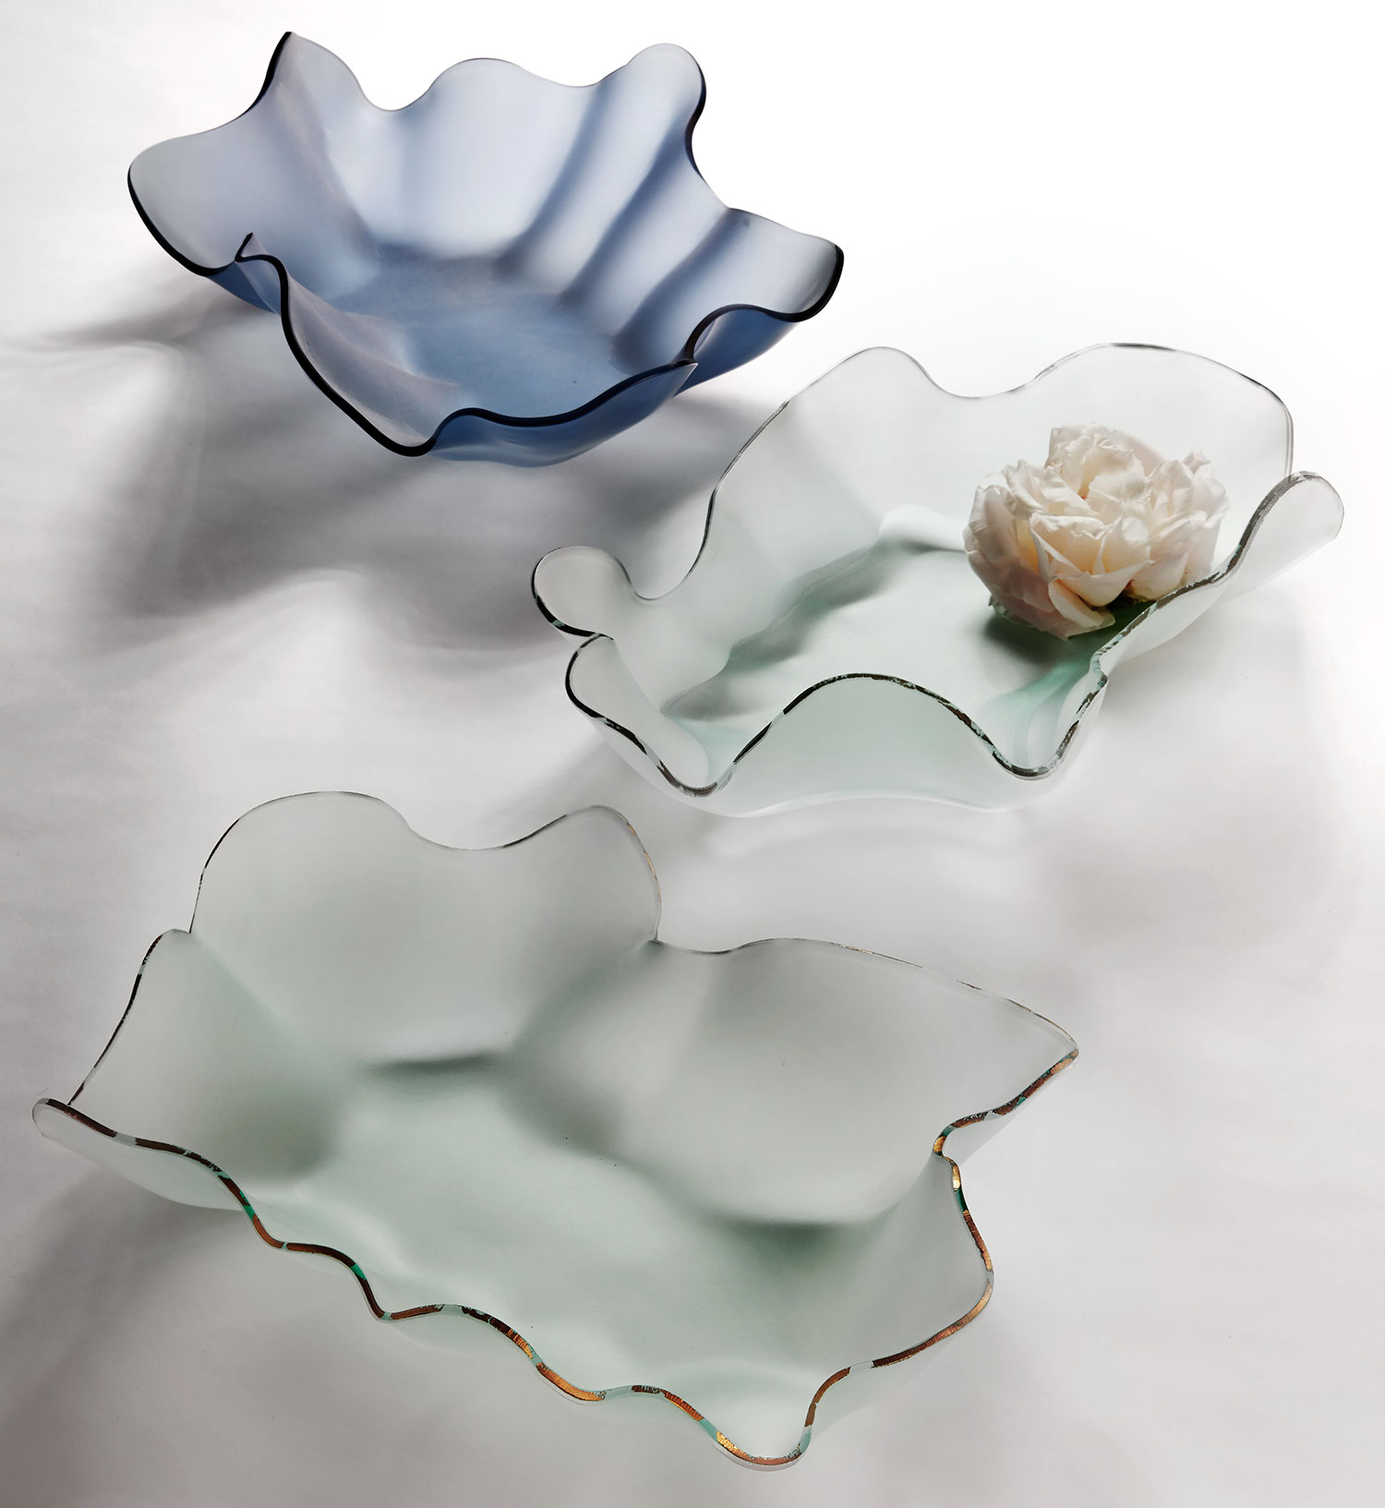
SCULPTURE LARGE HYDRA + PETAL
Originally inspired by explorations of the Monterey Bay tide pools near her California home, Annie has designed two additions to the sculpture Hydra family, celebrating her unique glass slumping process. These additions include the Large Hydra Frosted 24k gold + platinum
28 x 12 x 5” HY100G or P is $420 MSRP.

The new Petal sculptural bowl appears delicate, soft in design, and calls to mind a single rose petal. Due to the popularity of the original Hydra sculpture, customers requested additional variations, prompting Annie to create a smaller, more open version in both frosted and Indigo blue. This petal design is beautiful as a sculpture, home décor accent, shallow bowl or centerpiece. The speckled precious metal on the edge mimics the markings of an open mussel shell found by the sea. Petal Frosted 24k gold + platinum 15 x 22 x 4.5” F300G or P and the
Petal - Indigo 15 x 22 x 4.5” F300P are $284 MSRP.

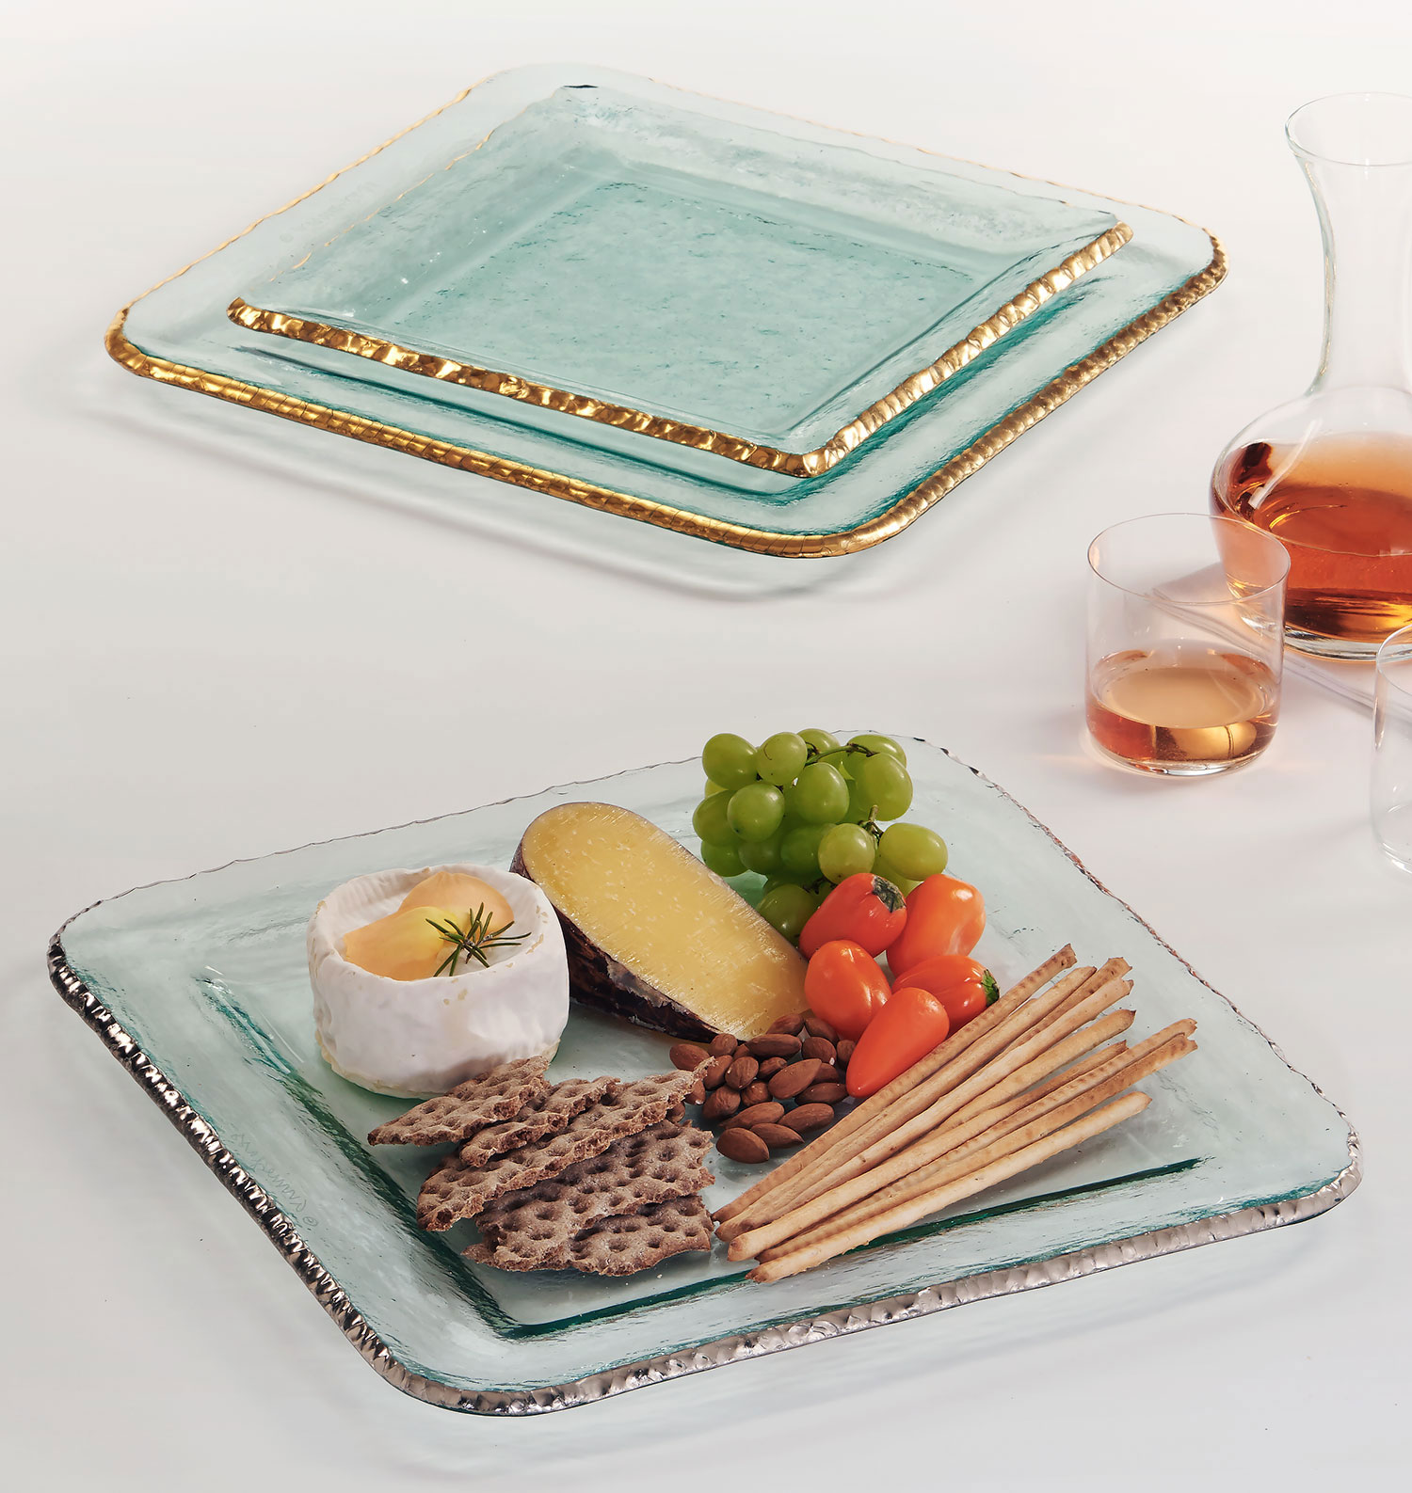
EDGEY 15” LARGE SQUARE PLATTER
Annieglass' new larger Edgey Square Platter 15.25 x 15.25” is the perfect answer to adding
a bit of gilded elegance to formal gatherings or as the perfect holiday or wedding gift. The impressive Edgey Square Platter is painstakingly made; first cut from thick glass, then hand
chipped, sanded and hand painted with precious metal luster, kiln fired and signed. Makes a
striking statement on any table whether used as a year-round centerpiece or filled with hors d’oeuvres at a cocktail party. E204G or P is $336 MSRP.

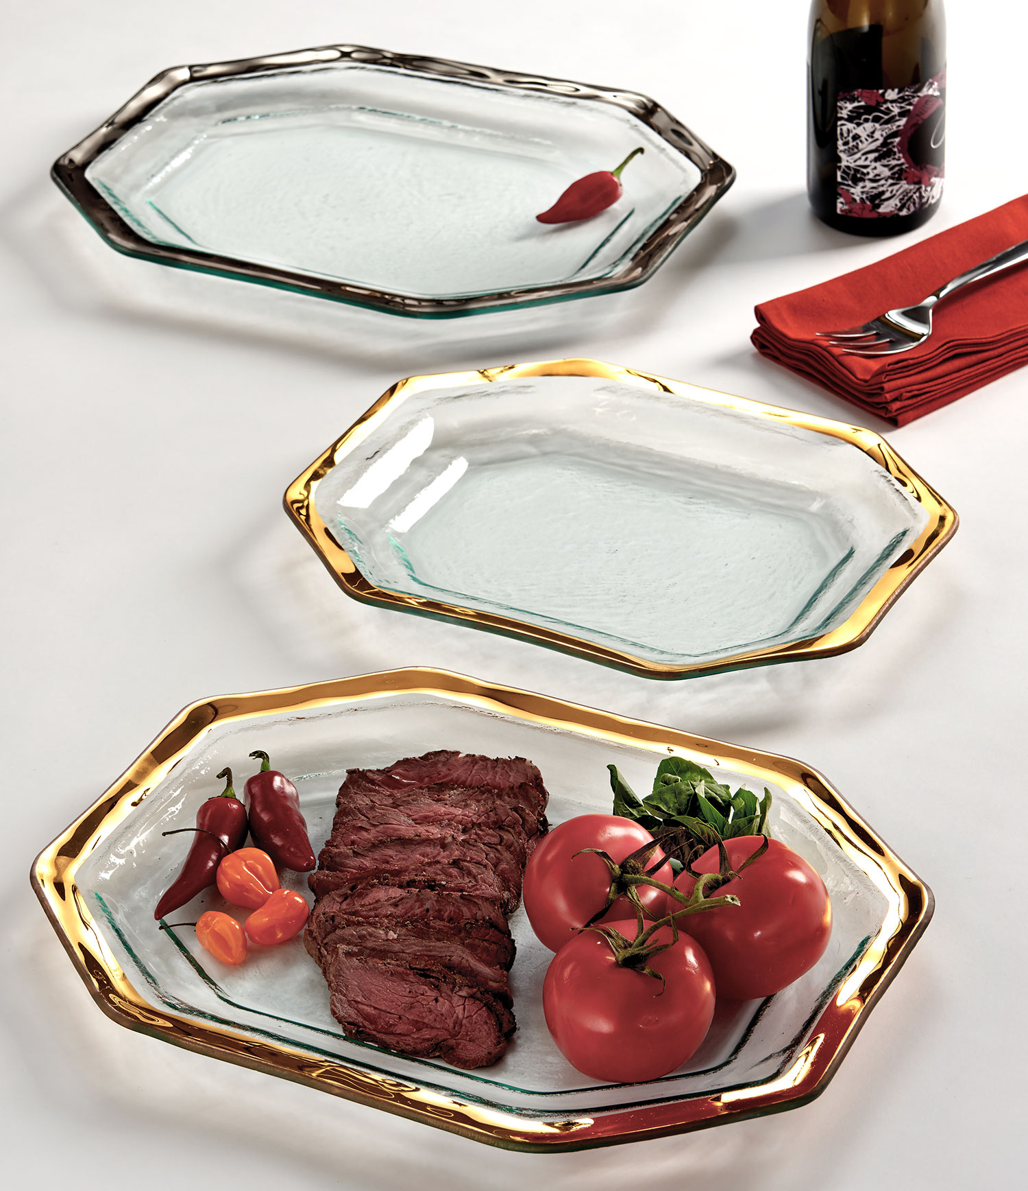
ROMAN ANTIQUE LARGE STEAK PLATTER
Forever evolving Annieglass’ most iconic and classic Roman Antique line, Annie introduces an even larger 16” Roman Antique Large Steak Platter at 16.25 x 12.5”, building on the momentum and demand of the recently released 14” Roman Antique Steak Platter. The octagonal-shaped serving piece is set with a deep base that allows chefs and home cooks alike to transport scratch-made
meals and barbecue to the table with ease. Annie’s unique melting process ensures the 24k gold edge is beautiful, durable and dishwasher safe. 230 G or P is $200 MSRP.

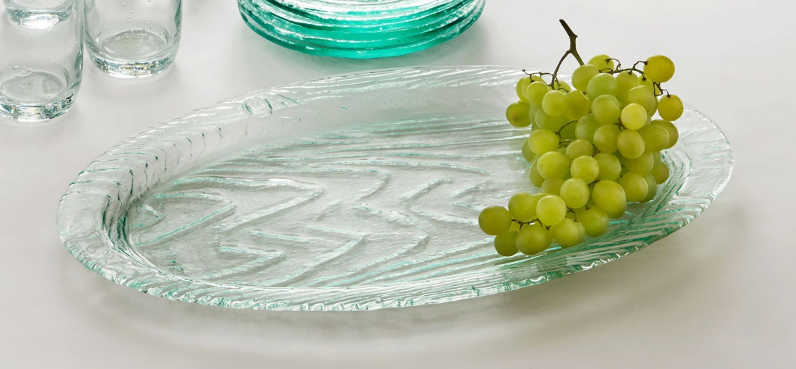
GROVE LARGE OVAL SERVING TRAY
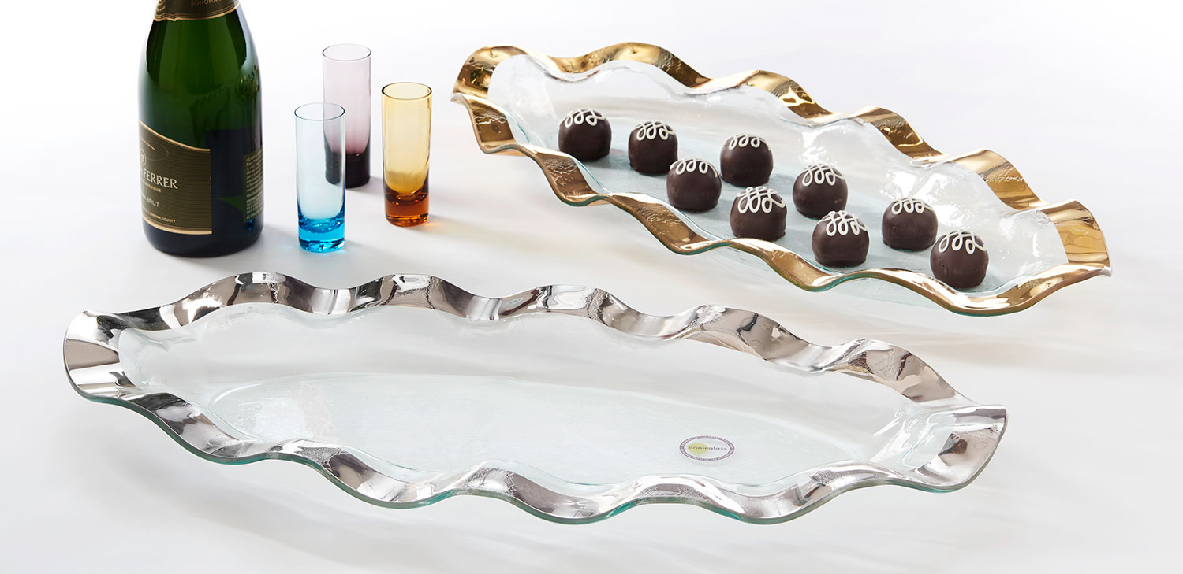
Annie introduces the Large Oval Serving Tray 19.5 x 13” and is a much-needed addition to the Annieglass Grove Collection. Customers asked for a larger serving platter to go with the wildly popular wood design. Sustainably handmade in California, this perfectly-green line is textured from natural wood grain of an actual tree and brings a casual, light-hearted touch to brunches, bridal showers and gift giving. GE116 is $105 MSRP.

RUFFLE LARGE OVAL PLATTER, GOLD + PLATINUM
Adored for its beauty and graceful, elegant movement the Ruffle collection is one of Annie’s most popular. Feminine ruffled accents create an undulating ribbon-like oval, flattering any table as the statement piece to own. 232G or P is $305 MSRP.

Annieglass is a leader in handcrafted luxury glassware. Made sustainably in their Watsonville studio on California’s central coast, Annieglass captures the beauty of imperfection through a special “slumping” process innovated by artist/owner Annie Morhauser. Combining artisanal techniques with new technology, Annie’s imaginative designs are cut into glass, which is set into kilns at high temperatures; the glass then drapes over molds, stretching into individual patterns and rendering each piece of Annieglass a unique work of art. Annieglass’ handcrafted process ensures dishwasher safety, durability and a lifetime of use from the finished luxury glassware. Each piece is hand-engraved with a studio signature for authenticity. Coveted by brides, celebrities, chefs and home collectors, Annieglass can be found in the finest stores, and is on permanent display at the Smithsonian American Art Museum.

Media Contact:  Rena Ramirez or  Rebecca Eisenberg  Provocateur Media  rena@provocateur-media.com; rebecca@provocateur-media.com  o. 415.513.5883  Company Name:  Annieglass, Inc.  Owner and Creative Director:  Annie Morhauser  Date Founded:  July 3, 1983  Company Address:  310 Harvest Drive  Watsonville, CA 95076  Phone: 800- 347-6133  Website:  annieglass.com  Facebook:  facebook.com/annieglassinc  Instagram:  Annieglass Inc  Twitter:  Annieglass Inc  Pinterest:  Annieglass Inc | National Retailers Bloomingdale’s Neiman Marcus  Fine Independent Retail Stores Nationwide  Company Retail Stores  Watsonville Retail Store  & Production Studio  310 Harvest Drive  Watsonville, CA 95076  831-761-2041 ext 21  Santana Row Retail Store  377 Santana Row, Ste 1105  San Jose, CA 95128  408-753-9115 | Museum Collections  Smithsonian American Art Museum  Washington D.C.  Gallery of Modern Art Glasgow, Scotland  Corning Museum of Glass,  Corning, NY

