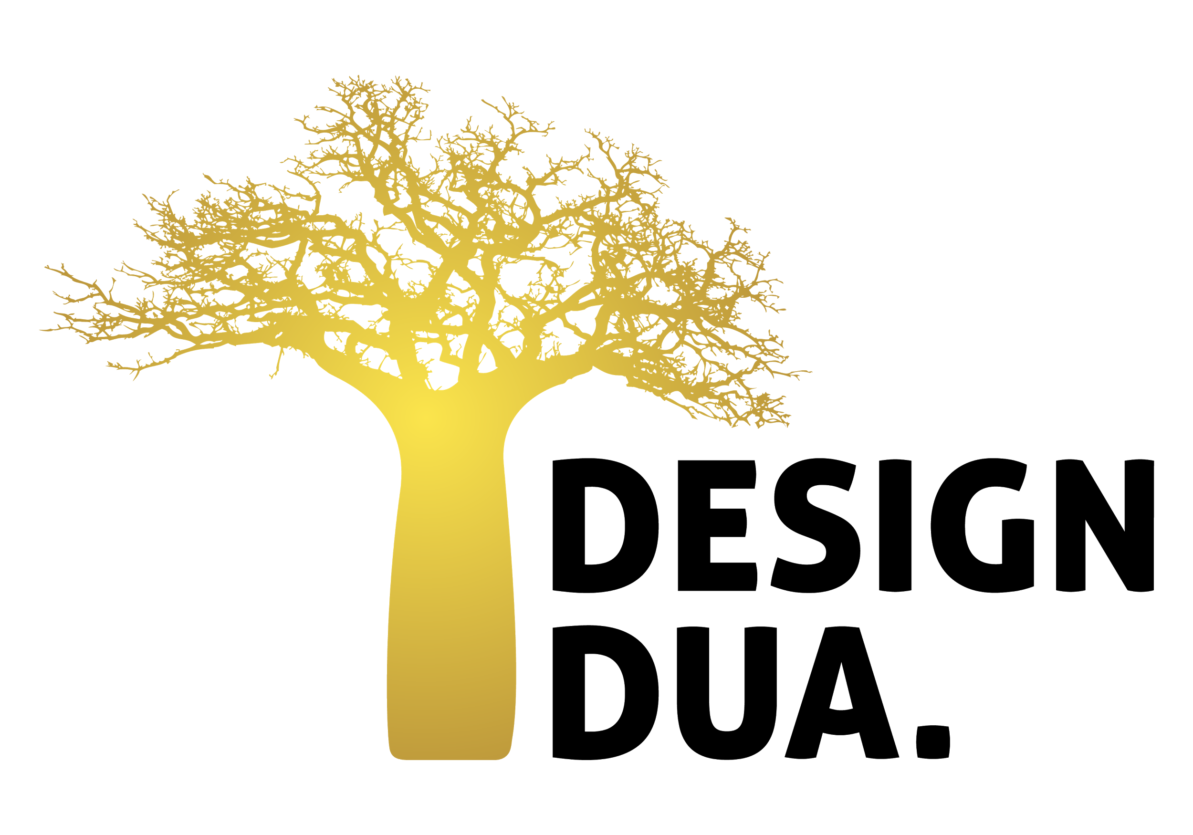
For Immediate Release
Design Dua: Bringing Designs from Traditional Artisans Into Your Homes
From the skilled hands of African artisans, Design Dua baskets are quickly cornering the baby products market. Design Dua is a Washington and Accra-based design company dedicated to changing the artisan craft industry in Ghana to help thousands of talented artisans earn a fair wage.
“Our most popular baskets are the Bilia baby bassinets,” said Coretta Owusu, the founder of Design Dua. “Our baskets have quickly become popular because, not only are they handmade, but they are made with quality in mind. We are standardizing our basket making process so that the true beauty of our craft can show in each and every purchase.”
In Ghana’s Upper East region, thousands of the rural poor possess an incredible skill: elephant grass basket weaving. Yet for hundreds of years, it has remained one of Ghana’s poorest regions and the basket industry continues to lack the innovation needed to foster change. Most baskets are sold to wholesalers and marketed internationally, but many of the weavers are not paid decent wages and are struggling to make it by on a day-to-day basis. Without business education and proper skills training, weavers are left with little knowledge of how to properly design, market, and sell their goods.
Design Dua is making waves in the basket industry by working with artisans to create high-quality, beautifully designed products for the home and family. Design Dua focuses on training artisans to create products that are consistent and in line with international quality standards. Not only is the company improving the products made in the region, it is improving the lives of artisans by providing a fair and reliable wage.
“Each large basket takes days to complete from start to finish. Many artisans were underpaid for their work and found it difficult to buy materials while also meeting their daily needs,” Owusu said. Since February of this year, Design Dua has worked with artisans to provide wholesale materials and training to over forty artisans. Design Dua currently sells their products to customers all over the world and hopes to introduce their products to more retailers through their exhibit at the August NY NOW show in the Handmade Global Design Section Booth: 628.

Find out more about Design Dua at:

Design Dua | Instagram | Facebook | Twitter

Email: hello@designdua.com

