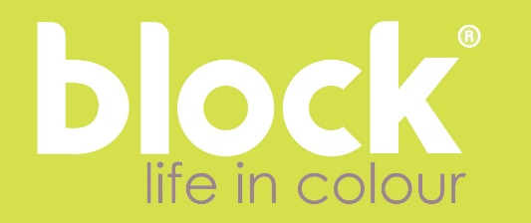
Origami Fold Clock
The latest clock collection from Block applies principal Origami folds to steel, creating shifting interactions between light and colour throughout the day.
‘Our starting point,’ says designer Tara Ashe, ‘was a paring back of clock design to its essential qualities. We realised early on in the process that the vertical line was fundamental to the measurement of time; that the human eye is habituated to seeing 12:00 with the subtlest of visual cues.’
Having recently taken a research trip in Japan, it was a logical progression for Tara to replace the line with a fold. ‘I returned from Japan feeling that I had visited a nation of designers’, she recalls, ‘I was fascinated by the beautiful precision I met in every aspect of Japanese life and particularly by the impact that could be achieved with a simple fold. In the Origami Fold Clock I wanted to experiment with the effect a fold would have on colour and its relationship to changes in light and shade.’
The Origami Fold Clock is packaged with care and attention to detail. Each Clock is supplied in a bespoke box illustrated with a specially commissioned piece of graphic design.
Formed in 2000 by designer Tara Ashe, Block design studio creates unique home and deskware characterised by unflinching colour and line. Block products are informed by a careful study of colour trends and interactions and are realised by industry specialists committed to ethical and high quality production.

